# Race: AQU | 2025-03-30 | Race #1 | Post: 13:10 | Track: AQUEDUCT

Track: AQUEDUCT

|  |  |  |  |  |  |
| --- | --- | --- | --- | --- | --- |
| Program # | Horse Name | Morn Odds | GCSF | Model Score | Win Prob (%) |
| 1 | Return the Ring | 13-8 | 109.2 | 0.78 | 2.14 |
| 1A | Augustine Red | 13-8 | 108.3 | 1.48 | 34.26 |
| 2 | Steady Progress | 30-1 | 82.9 | 0.83 | 2.77 |
| 3 | Golden Candy | 4-1 | 104.3 | 1.36 | 23.98 |
| 4 | Vinsanity | 9-2 | 95.8 | 1.05 | 7.68 |
| 5 | Narciso Dali | 3-1 | 98.1 | 1.36 | 24.26 |
| 6 | Paxsational | 7-2 | 99.7 | 0.95 | 4.91 |

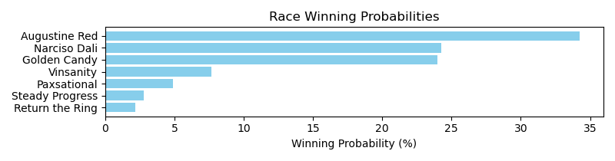

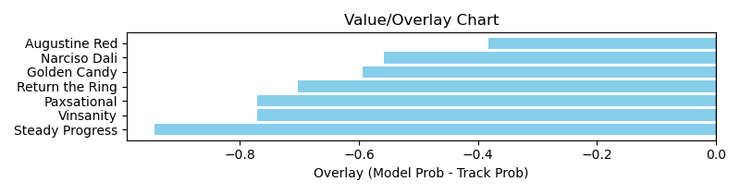

NOTE: GCSF - Global Combined Speed Figure

# Race: AQU | 2025-03-30 | Race #2 | Post: 13:45 | Track: AQUEDUCT

Track: AQUEDUCT

|  |  |  |  |  |  |
| --- | --- | --- | --- | --- | --- |
| Program # | Horse Name | Morn Odds | GCSF | Model Score | Win Prob (%) |
| 1 | KYLE'S MOM | 8-1 | 100.0 | 1.01 | 10.66 |
| 2 | On a Proud Note | 3-1 | 100.0 | 1.21 | 23.92 |
| 3 | Melancia | 7-5 | 88.6 | 1.27 | 29.03 |
| 4 | Katerina Ristova | 20-1 | 92.0 | 0.57 | 0.89 |
| 5 | Teca | 5-2 | 93.4 | 0.83 | 4.51 |
| 6 | Aerialist | 12-1 | 100.0 | 0.98 | 9.26 |
| 7 | Just Words | 12-1 | 89.4 | 1.19 | 21.74 |

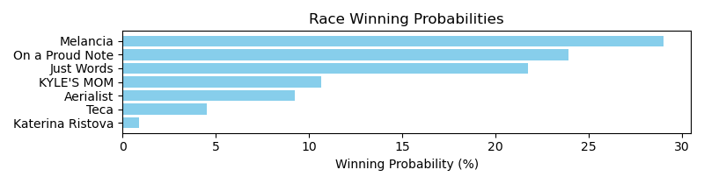

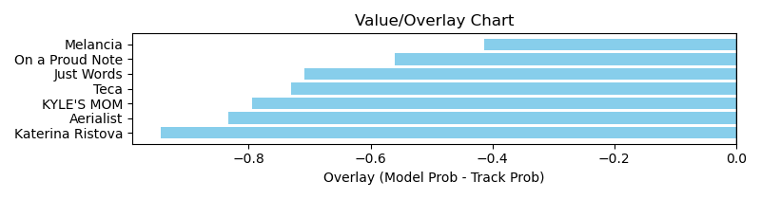

NOTE: GCSF - Global Combined Speed Figure

# Race: AQU | 2025-03-30 | Race #3 | Post: 14:20 | Track: AQUEDUCT

Track: AQUEDUCT

|  |  |  |  |  |  |
| --- | --- | --- | --- | --- | --- |
| Program # | Horse Name | Morn Odds | GCSF | Model Score | Win Prob (%) |
| 1 | One Good Raison | 6-1 | 93.4 | 1.17 | 25.36 |
| 2 | Wake Up Lauren | 7-2 | 96.4 | 0.81 | 5.24 |
| 3 | R Special | 20-1 | 106.6 | 0.88 | 7.31 |
| 4 | Cajunette | 3-1 | 99.7 | 1.07 | 17.38 |
| 5 | The Splendid One | 12-1 | 96.6 | 0.86 | 6.57 |
| 6 | She's Wicked Smart | 2-1 | 112.4 | 1.06 | 16.34 |
| 7 | Lumenique | 4-1 | 109.6 | 1.13 | 21.81 |

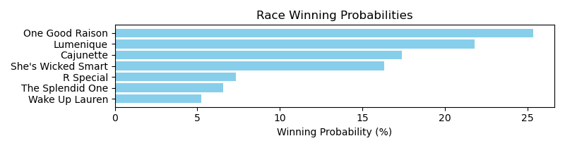

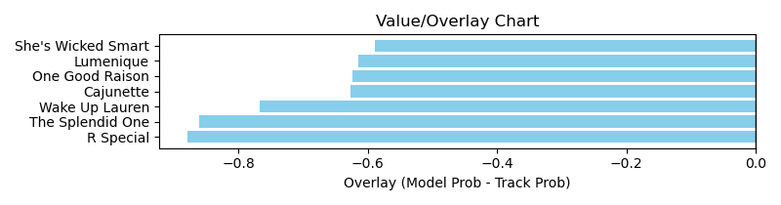

NOTE: GCSF - Global Combined Speed Figure

# Race: AQU | 2025-03-30 | Race #4 | Post: 14:52 | Track: AQUEDUCT

Track: AQUEDUCT

|  |  |  |  |  |  |
| --- | --- | --- | --- | --- | --- |
| Program # | Horse Name | Morn Odds | GCSF | Model Score | Win Prob (%) |
| 1 | Aint No Joke | 6-5 | 93.1 | 1.07 | 20.87 |
| 1A | Blown Cover | 6-5 | 104.5 | 0.70 | 3.25 |
| 2 | Aelfgar | 10-1 | 90.2 | 0.94 | 11.48 |
| 3 | Mr. Papagiorgio | 9-5 | 97.0 | 0.86 | 7.74 |
| 4 | Magical Road | 15-1 | 88.9 | 0.95 | 12.31 |
| 5 | Messi the Magician | 5-1 | 95.0 | 1.09 | 21.95 |
| 6 | Majestic Arc | 20-1 | 107.2 | 0.81 | 5.98 |
| 7 | Noble Huntsman | 10-1 | 105.5 | 1.02 | 16.42 |

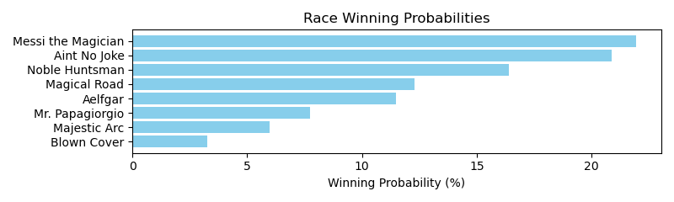

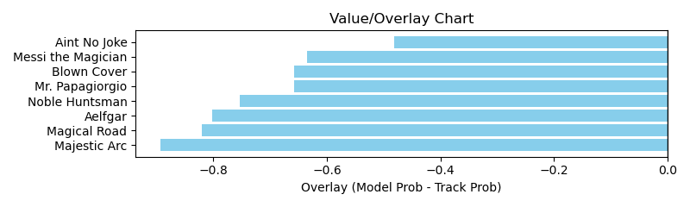

NOTE: GCSF - Global Combined Speed Figure

# Race: AQU | 2025-03-30 | Race #5 | Post: 15:24 | Track: AQUEDUCT

Track: AQUEDUCT

|  |  |  |  |  |  |
| --- | --- | --- | --- | --- | --- |
| Program # | Horse Name | Morn Odds | GCSF | Model Score | Win Prob (%) |
| 1 | Into Stardom | 6-5 | 100.0 | 1.56 | 32.92 |
| 2 | Chocolatechocolate | 6-1 | 100.0 | 1.21 | 11.12 |
| 3 | Calling an Audible | 5-1 | 109.2 | 1.20 | 10.61 |
| 4 | Our Preferred Pal | 10-1 | 88.8 | 0.97 | 4.24 |
| 5 | Otherpeoplesmoney | 30-1 | 100.0 | 1.12 | 7.81 |
| 6 | WORK AWAY | 4-1 | 100.0 | 1.26 | 12.99 |
| 7 | Sounds of Summer | 9-2 | 100.0 | 1.39 | 20.30 |

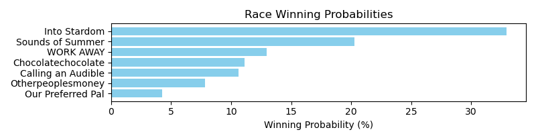

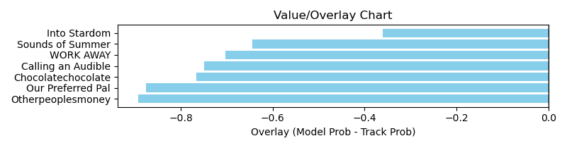

NOTE: GCSF - Global Combined Speed Figure

# Race: AQU | 2025-03-30 | Race #6 | Post: 15:57 | Track: AQUEDUCT

Track: AQUEDUCT

|  |  |  |  |  |  |
| --- | --- | --- | --- | --- | --- |
| Program # | Horse Name | Morn Odds | GCSF | Model Score | Win Prob (%) |
| 1 | Drive Thru | 4-1 | 108.0 | 1.04 | 19.84 |
| 1A | Solo Flight | 4-1 | 100.4 | 0.74 | 4.39 |
| 2 | Prairie Dunes | 8-1 | 93.1 | 0.92 | 11.73 |
| 3 | True Connection | 5-2 | 93.5 | 1.12 | 27.79 |
| 4 | Henry's Hope | 20-1 | 93.4 | 0.62 | 2.08 |
| 5 | Beach Blanket | 7-2 | 93.4 | 0.78 | 5.52 |
| 6 | Change Your Name | 6-1 | 106.6 | 0.74 | 4.57 |
| 7 | Belmont Union | 12-1 | 106.6 | 0.58 | 1.60 |
| 8 | Fly'n Frisbee | 9-2 | 100.0 | 1.07 | 22.48 |

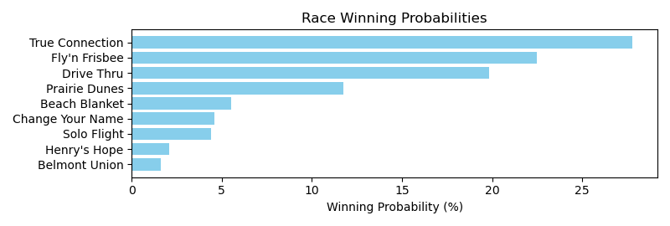

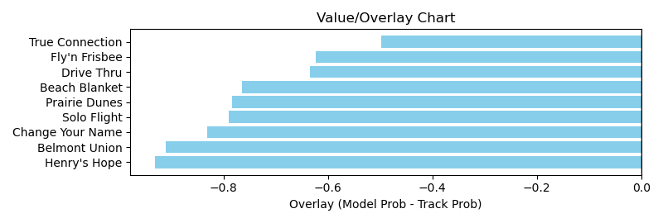

NOTE: GCSF - Global Combined Speed Figure

# Race: AQU | 2025-03-30 | Race #7 | Post: 16:30 | Track: AQUEDUCT

Track: AQUEDUCT

|  |  |  |  |  |  |
| --- | --- | --- | --- | --- | --- |
| Program # | Horse Name | Morn Odds | GCSF | Model Score | Win Prob (%) |
| 1 | Uncaged | 9-5 | 100.0 | 1.31 | 18.49 |
| 2 | Jerry's Out | 8-1 | 95.9 | 1.25 | 14.90 |
| 3 | Uncle Jim | 2-1 | 93.4 | 1.13 | 9.83 |
| 4 | On the Mount | 9-2 | 100.0 | 1.50 | 33.10 |
| 5 | Toga d'Oro | 4-1 | 100.0 | 1.30 | 17.76 |
| 6 | Steel Vengeance | 15-1 | 101.9 | 0.75 | 1.60 |
| 7 | Stormin Sammy | 30-1 | 104.9 | 0.94 | 4.32 |

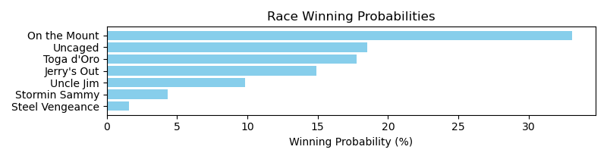

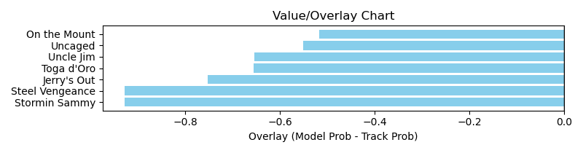

NOTE: GCSF - Global Combined Speed Figure

# Race: AQU | 2025-03-30 | Race #8 | Post: 17:02 | Track: AQUEDUCT

Track: AQUEDUCT

|  |  |  |  |  |  |
| --- | --- | --- | --- | --- | --- |
| Program # | Horse Name | Morn Odds | GCSF | Model Score | Win Prob (%) |
| 1 | Commandperformance | 10-1 | 107.1 | 1.06 | 10.10 |
| 2 | Allaboutthemoney | 15-1 | 96.9 | 0.82 | 3.29 |
| 3 | Ice Road | 4-1 | 104.9 | 1.50 | 46.42 |
| 4 | Co Conspirator | 50-1 | 97.3 | 0.74 | 2.12 |
| 5 | Afraidofthebunny | 9-5 | 99.3 | 0.98 | 7.04 |
| 6 | Majestic Frontier | 5-1 | 105.2 | 1.15 | 14.66 |
| 8 | Bossmakinbossmoves | 5-2 | 106.4 | 1.05 | 9.75 |
| 9 | Kahala | 10-1 | 105.1 | 0.96 | 6.61 |

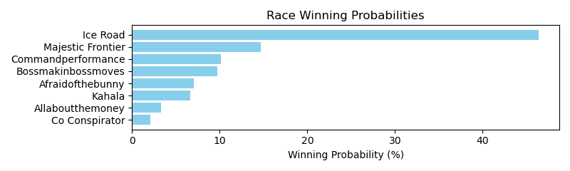

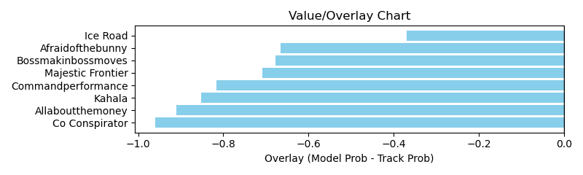

NOTE: GCSF - Global Combined Speed Figure

# Race: TGP | 2025-03-30 | Race #1 | Post: 12:50 | Track: GULFSTREAM PARK

Track: GULFSTREAM PARK

|  |  |  |  |  |  |
| --- | --- | --- | --- | --- | --- |
| Program # | Horse Name | Morn Odds | GCSF | Model Score | Win Prob (%) |
| 1 | THREE LITTLE BIRDS | 6-1 | 100.0 | 1.19 | 8.95 |
| 2 | MISSPENT YOUTH | 20-1 | 100.0 | 1.06 | 5.45 |
| 3 | JOE IS HERE | 7-2 | 100.0 | 1.31 | 13.43 |
| 4 | How About It | 8-1 | 95.0 | 1.20 | 9.26 |
| 5 | Hello Jello | 9-2 | 100.0 | 1.46 | 21.94 |
| 6 | Gettin' There | 4-1 | 100.0 | 1.51 | 24.95 |
| 7 | EXPECT THE BEST | 10-1 | 100.0 | 1.13 | 7.13 |
| 8 | KEEP ON MOVING | 5-2 | 100.0 | 1.19 | 8.89 |

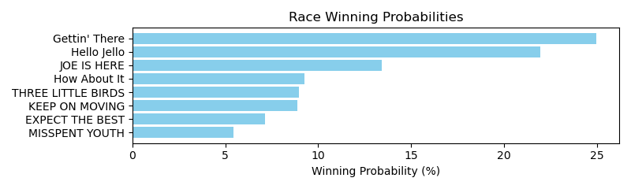

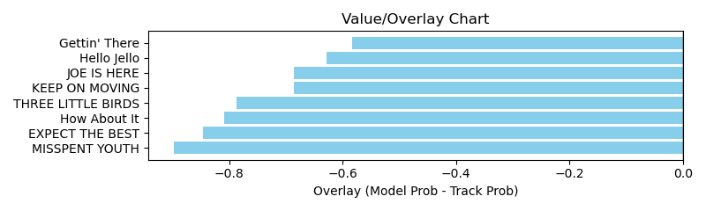

NOTE: GCSF - Global Combined Speed Figure

# Race: TGP | 2025-03-30 | Race #2 | Post: 13:23 | Track: GULFSTREAM PARK

Track: GULFSTREAM PARK

|  |  |  |  |  |  |
| --- | --- | --- | --- | --- | --- |
| Program # | Horse Name | Morn Odds | GCSF | Model Score | Win Prob (%) |
| 1 | Watsonville Red | 30-1 | 106.6 | 0.82 | 1.72 |
| 2 | Nudge | 9-5 | 100.0 | 1.45 | 20.14 |
| 3 | NEMO | 10-1 | 100.0 | 1.09 | 5.88 |
| 4 | Proudly Hailed (GB) | 7-2 | 100.0 | 1.47 | 21.85 |
| 5 | Eleven Bravo | 8-1 | 93.3 | 0.81 | 1.60 |
| 6 | War Legend | 8-1 | 100.0 | 1.07 | 5.47 |
| 7 | Timayyyy | 4-1 | 100.0 | 1.47 | 21.73 |
| 8 | Cash the Money | 15-1 | 97.3 | 1.18 | 8.15 |
| 9 | No Escape | 8-1 | 100.0 | 1.32 | 13.46 |

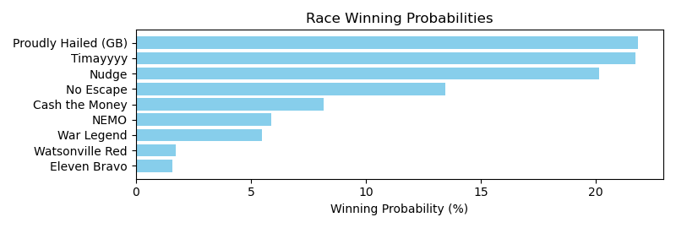

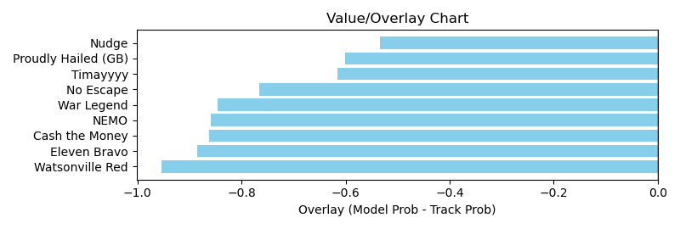

NOTE: GCSF - Global Combined Speed Figure

# Race: TGP | 2025-03-30 | Race #3 | Post: 13:56 | Track: GULFSTREAM PARK

Track: GULFSTREAM PARK

|  |  |  |  |  |  |
| --- | --- | --- | --- | --- | --- |
| Program # | Horse Name | Morn Odds | GCSF | Model Score | Win Prob (%) |
| 1 | Ambushed | 30-1 | 100.2 | 0.78 | 2.74 |
| 2 | Breezer | 20-1 | 113.9 | 0.66 | 1.32 |
| 3 | Song So Sweet | 30-1 | 92.1 | 1.19 | 17.16 |
| 4 | Premiado | 10-1 | 95.6 | 0.95 | 6.51 |
| 5 | Moonrise Drive | 20-1 | 89.5 | 0.77 | 2.63 |
| 6 | Kosher Capone | 9-5 | 99.9 | 1.15 | 14.79 |
| 7 | Downing Street | 3-1 | 98.9 | 0.86 | 4.16 |
| 8 | Who's the King | 9-2 | 104.4 | 1.15 | 15.03 |
| 9 | Bean Machine | 20-1 | 93.2 | 0.80 | 3.01 |
| 10 | Line Astray | 4-1 | 96.8 | 1.38 | 32.65 |

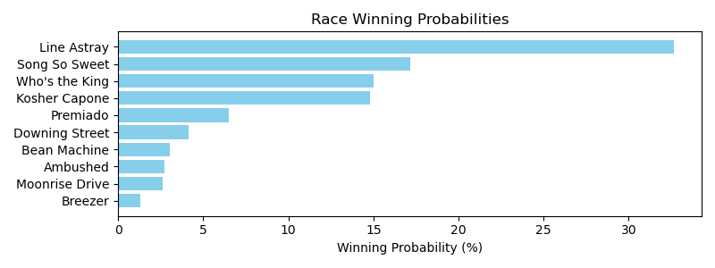

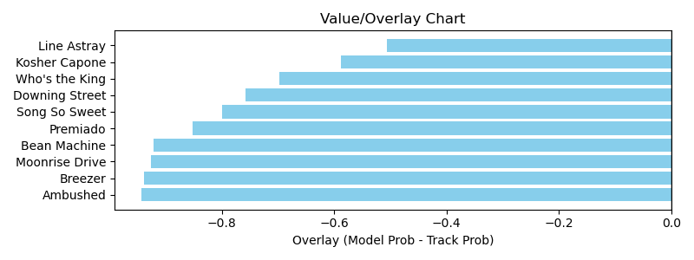

NOTE: GCSF - Global Combined Speed Figure

# Race: TGP | 2025-03-30 | Race #4 | Post: 14:27 | Track: GULFSTREAM PARK

Track: GULFSTREAM PARK

|  |  |  |  |  |  |
| --- | --- | --- | --- | --- | --- |
| Program # | Horse Name | Morn Odds | GCSF | Model Score | Win Prob (%) |
| 1 | Notorious | 2-1 | 100.0 | 1.22 | 24.02 |
| 2 | Zaddy | 20-1 | 95.9 | 0.92 | 7.06 |
| 3 | Bernardo's Legacy | 10-1 | 93.0 | 1.15 | 18.72 |
| 4 | Prince David | 6-1 | 97.8 | 0.77 | 3.15 |
| 5 | Yadirayadirayadira | 30-1 | 100.0 | 0.93 | 7.45 |
| 6 | Insanity It Seems | 5-2 | 97.4 | 0.90 | 6.28 |
| 7 | Siete Siete Siete | 8-1 | 100.0 | 1.08 | 14.25 |
| 8 | Outta Money | 12-1 | 100.0 | 1.00 | 10.07 |
| 9 | Ayman | 10-1 | 94.3 | 0.90 | 6.29 |
| 10 | Max N Fifo | 12-1 | 95.3 | 0.74 | 2.69 |

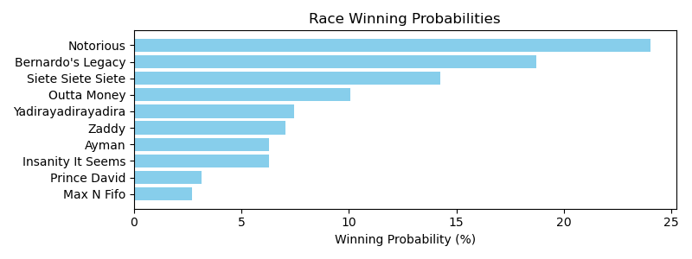

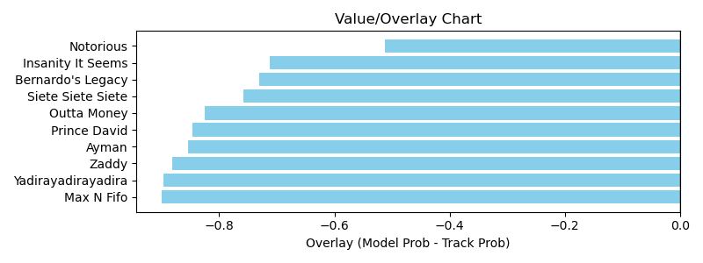

NOTE: GCSF - Global Combined Speed Figure

# Race: TGP | 2025-03-30 | Race #5 | Post: 15:00 | Track: GULFSTREAM PARK

Track: GULFSTREAM PARK

|  |  |  |  |  |  |
| --- | --- | --- | --- | --- | --- |
| Program # | Horse Name | Morn Odds | GCSF | Model Score | Win Prob (%) |
| 1 | Nate the Great | 8-1 | 115.3 | 1.53 | 14.63 |
| 2 | Samaritano | 15-1 | 89.8 | 1.42 | 10.64 |
| 3 | Mobou | 5-1 | 99.1 | 1.71 | 23.43 |
| 4 | Castagno | 20-1 | 96.7 | 1.03 | 2.53 |
| 5 | Forwardly | 30-1 | 95.7 | 0.81 | 0.92 |
| 6 | Light Fury | 2-1 | 103.0 | 1.11 | 3.53 |
| 7 | War Beat | 7-2 | 102.0 | 1.68 | 21.92 |
| 8 | Belly of Jelly | 9-2 | 100.7 | 1.16 | 4.35 |
| 9 | Lord of War | 6-1 | 97.6 | 1.61 | 18.05 |

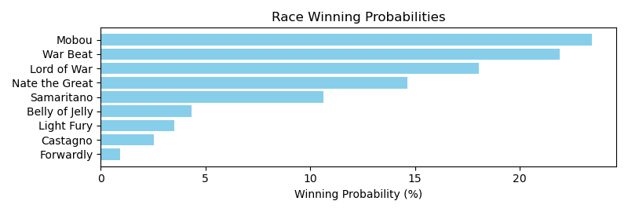

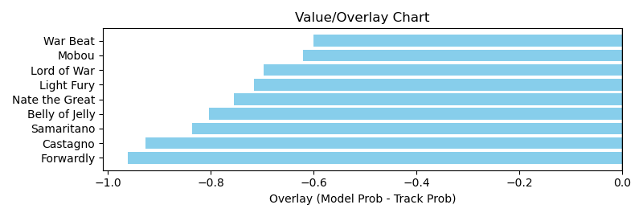

NOTE: GCSF - Global Combined Speed Figure

# Race: TGP | 2025-03-30 | Race #6 | Post: 15:30 | Track: GULFSTREAM PARK

Track: GULFSTREAM PARK

|  |  |  |  |  |  |
| --- | --- | --- | --- | --- | --- |
| Program # | Horse Name | Morn Odds | GCSF | Model Score | Win Prob (%) |
| 1 | LIAM'S LUCKY LADY | 20-1 | 100.0 | 1.13 | 10.18 |
| 2 | OPPOSE | 12-1 | 100.0 | 1.16 | 11.41 |
| 3 | Laulauga | 7-2 | 100.0 | 1.22 | 14.30 |
| 4 | Luna Louska | 20-1 | 100.0 | 1.11 | 9.47 |
| 5 | SURPRISE | 9-5 | 100.0 | 1.21 | 13.46 |
| 6 | Viveca | 12-1 | 100.0 | 1.17 | 11.72 |
| 7 | PALM DESERT | 8-1 | 100.0 | 1.09 | 8.72 |
| 8 | Kapoor | 2-1 | 100.0 | 1.33 | 20.74 |

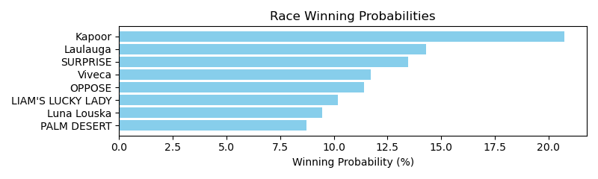

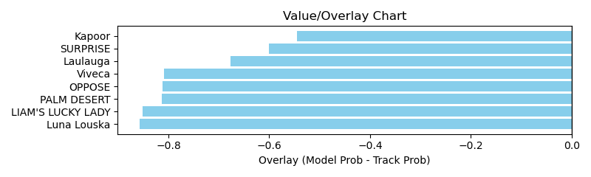

NOTE: GCSF - Global Combined Speed Figure

# Race: TGP | 2025-03-30 | Race #7 | Post: 16:05 | Track: GULFSTREAM PARK

Track: GULFSTREAM PARK

|  |  |  |  |  |  |
| --- | --- | --- | --- | --- | --- |
| Program # | Horse Name | Morn Odds | GCSF | Model Score | Win Prob (%) |
| 1 | Wink of an Eye | 20-1 | 106.7 | 1.34 | 26.31 |
| 2 | Awesomely Wild | 20-1 | 105.6 | 1.01 | 7.83 |
| 3 | My Happy Holiday | 15-1 | 90.5 | 0.97 | 6.54 |
| 4 | Fashionable Kitty | 30-1 | 90.9 | 0.65 | 1.13 |
| 5 | Gimme Mo Baby | 3-1 | 105.7 | 1.15 | 13.71 |
| 6 | Rue de Mosel Tov | 10-1 | 106.6 | 0.59 | 0.74 |
| 7 | Bossy Diva | 20-1 | 116.3 | 0.61 | 0.88 |
| 8 | Free to Roam | 7-2 | 91.8 | 1.11 | 11.45 |
| 9 | Kilkenny Bella | 30-1 | 95.8 | 0.80 | 2.75 |
| 10 | Carrington | 5-2 | 114.9 | 0.96 | 6.09 |
| 11 | Dialithic | 12-1 | 92.5 | 1.12 | 12.29 |
| 12 | Arisaema | 10-1 | 109.9 | 1.08 | 10.28 |

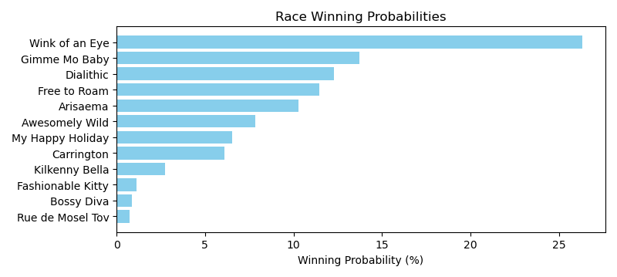

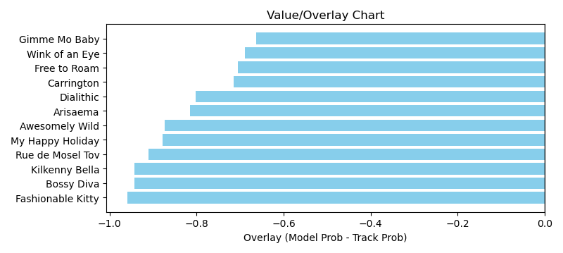

NOTE: GCSF - Global Combined Speed Figure

# Race: TGP | 2025-03-30 | Race #8 | Post: 16:45 | Track: GULFSTREAM PARK

Track: GULFSTREAM PARK

|  |  |  |  |  |  |
| --- | --- | --- | --- | --- | --- |
| Program # | Horse Name | Morn Odds | GCSF | Model Score | Win Prob (%) |
| 1 | Camp Evans | 8-1 | 100.0 | 1.18 | 10.43 |
| 2 | Majorca | 8-1 | 93.4 | 0.86 | 2.66 |
| 3 | Shotgun | 30-1 | 100.0 | 1.08 | 7.16 |
| 4 | Only in America | 2-1 | 100.0 | 1.43 | 24.22 |
| 5 | Meritorious | 9-2 | 100.0 | 1.26 | 14.13 |
| 6 | Shangrala Road | 13-8 | 100.0 | 1.37 | 20.20 |
| 7 | BALINO | 20-1 | 100.0 | 1.09 | 7.56 |
| 8 | Chillax | 12-1 | 100.0 | 1.25 | 13.64 |

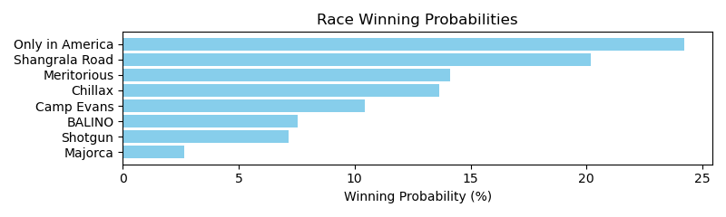

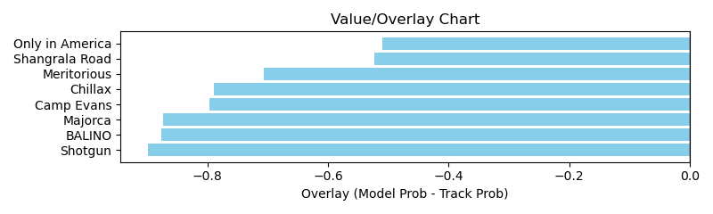

NOTE: GCSF - Global Combined Speed Figure

# Race: TGP | 2025-03-30 | Race #9 | Post: 17:20 | Track: GULFSTREAM PARK

Track: GULFSTREAM PARK

|  |  |  |  |  |  |
| --- | --- | --- | --- | --- | --- |
| Program # | Horse Name | Morn Odds | GCSF | Model Score | Win Prob (%) |
| 1 | Lookin At Roses | 8-1 | 96.4 | 0.90 | 4.11 |
| 2 | Billy the Greek | 2-1 | 95.0 | 1.43 | 31.10 |
| 3 | Bold Looker | 5-2 | 98.5 | 1.09 | 9.23 |
| 4 | Pirate Radio | 30-1 | 98.6 | 0.79 | 2.30 |
| 5 | Royal Act | 20-1 | 100.8 | 0.93 | 4.64 |
| 6 | McMoney | 9-2 | 96.3 | 1.27 | 18.35 |
| 7 | Speight'spercomete | 12-1 | 95.8 | 0.93 | 4.77 |
| 8 | Cross Haste | 15-1 | 123.3 | 0.88 | 3.71 |
| 9 | Top Recruit | 8-1 | 100.1 | 0.96 | 5.49 |
| 10 | Thethrillofvictory | 15-1 | 95.5 | 1.24 | 16.28 |

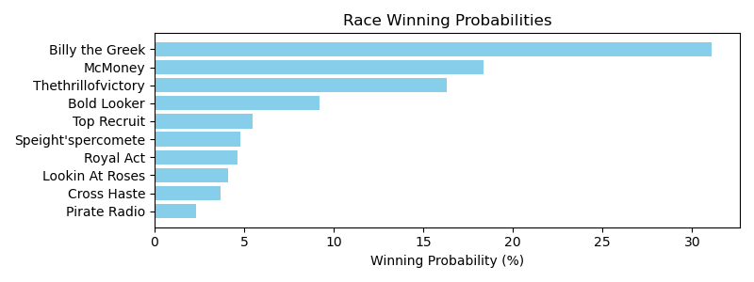

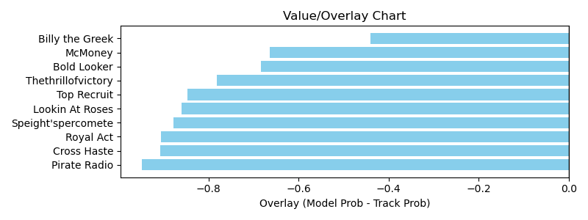

NOTE: GCSF - Global Combined Speed Figure

# Race: TGP | 2025-03-30 | Race #10 | Post: 17:50 | Track: GULFSTREAM PARK

Track: GULFSTREAM PARK

|  |  |  |  |  |  |
| --- | --- | --- | --- | --- | --- |
| Program # | Horse Name | Morn Odds | GCSF | Model Score | Win Prob (%) |
| 1 | ROYALTY RATE | 5-1 | 100.0 | 1.10 | 6.77 |
| 2 | MILDRED PIERCE | 9-2 | 100.0 | 1.28 | 13.18 |
| 3 | Restless Dreamer | 7-2 | 99.6 | 1.21 | 10.32 |
| 4 | Counterinteligence (GB) | 5-1 | 100.0 | 1.33 | 15.31 |
| 5 | Dancing On Our Own | 6-1 | 100.0 | 1.27 | 12.70 |
| 6 | Keytothepark | 15-1 | 106.3 | 0.70 | 0.96 |
| 7 | Taboo Mischief | 20-1 | 106.6 | 0.84 | 2.11 |
| 8 | Midsummer Mo | 12-1 | 96.1 | 1.29 | 13.65 |
| 9 | Annulled | 4-1 | 106.6 | 1.49 | 24.99 |

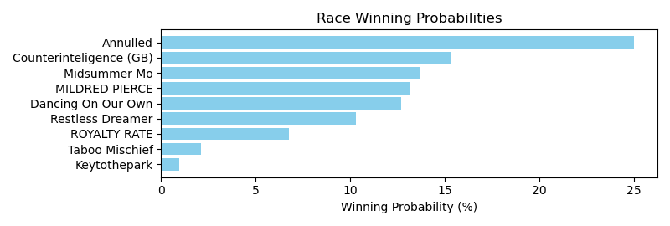

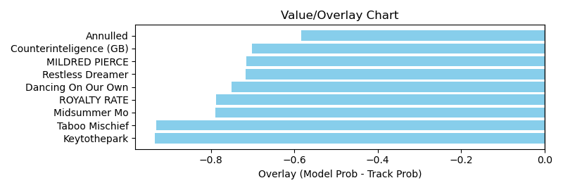

NOTE: GCSF - Global Combined Speed Figure

# Race: TGP | 2025-03-30 | Race #11 | Post: 18:20 | Track: GULFSTREAM PARK

Track: GULFSTREAM PARK

|  |  |  |  |  |  |
| --- | --- | --- | --- | --- | --- |
| Program # | Horse Name | Morn Odds | GCSF | Model Score | Win Prob (%) |
| 1 | Soulmate | 3-1 | 104.2 | 1.18 | 7.10 |
| 2 | Disattached | 10-1 | 92.3 | 1.03 | 3.95 |
| 3 | Stroke of Midnight | 8-1 | 96.8 | 1.23 | 8.43 |
| 4 | Ejtimaa | 10-1 | 96.6 | 1.24 | 8.73 |
| 5 | Lamplighter Jack | 5-1 | 98.0 | 1.56 | 23.59 |
| 6 | K. C. Chief | 9-2 | 95.9 | 1.65 | 30.01 |
| 7 | Alley Oop Johnny | 5-2 | 109.5 | 1.26 | 9.23 |
| 8 | Honesto | 15-1 | 99.2 | 1.11 | 5.33 |
| 9 | Fatima's Blessing | 20-1 | 104.1 | 1.02 | 3.63 |

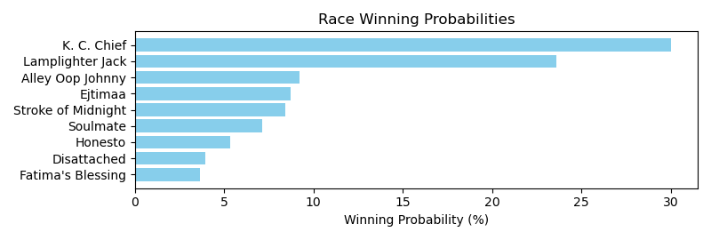

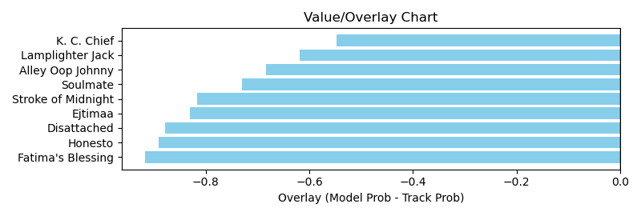

NOTE: GCSF - Global Combined Speed Figure

# Race: TGP | 2025-03-30 | Race #12 | Post: 18:50 | Track: GULFSTREAM PARK

Track: GULFSTREAM PARK

|  |  |  |  |  |  |
| --- | --- | --- | --- | --- | --- |
| Program # | Horse Name | Morn Odds | GCSF | Model Score | Win Prob (%) |
| 1 | Bit of Frost | 10-1 | 100.0 | 1.23 | 12.12 |
| 2 | Fallon | 20-1 | 93.4 | 0.68 | 0.92 |
| 3 | Baby Lala | 15-1 | 100.0 | 1.18 | 10.40 |
| 4 | Henry Gondorff | 15-1 | 106.6 | 0.71 | 1.12 |
| 5 | Keepthedreamalive | 9-2 | 106.6 | 1.19 | 10.66 |
| 6 | BIG MAGIC (IRE) | 6-1 | 100.0 | 1.02 | 5.50 |
| 7 | Bojaca Blessing | 6-1 | 93.4 | 0.94 | 3.79 |
| 8 | LOSECONTROL | 10-1 | 100.0 | 1.10 | 7.57 |
| 9 | SUTTON SUZIE | 20-1 | 100.0 | 1.20 | 10.91 |
| 10 | HIBISCUS | 8-1 | 100.0 | 1.20 | 11.10 |
| 11 | CAVIAR BREAKFAST | 30-1 | 100.0 | 1.13 | 8.62 |
| 12 | Obeissante | 5-2 | 100.0 | 1.33 | 17.30 |

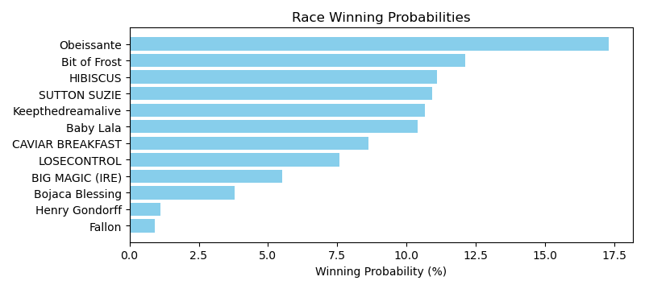

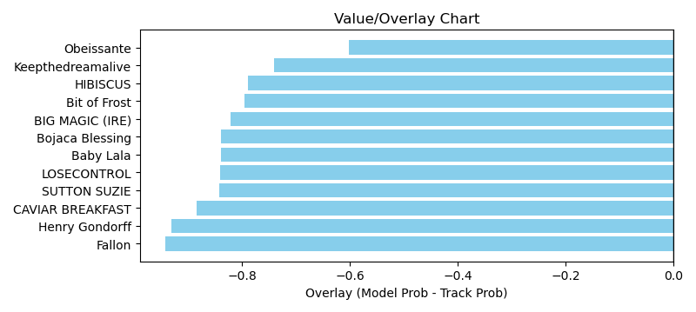

NOTE: GCSF - Global Combined Speed Figure

# Race: LRL | 2025-03-30 | Race #1 | Post: 12:10 | Track: LAUREL PARK

Track: LAUREL PARK

|  |  |  |  |  |  |
| --- | --- | --- | --- | --- | --- |
| Program # | Horse Name | Morn Odds | GCSF | Model Score | Win Prob (%) |
| 1 | Map to the Moon | 8-1 | 98.3 | 0.67 | 1.67 |
| 2 | Chestertown Jane | 4-1 | 100.0 | 1.24 | 24.74 |
| 3 | MOONLIGHT MISTRESS | 20-1 | 100.0 | 1.04 | 11.62 |
| 4 | Nearly a Lady | 12-1 | 90.2 | 0.62 | 1.23 |
| 5 | Warriors Jewel | 7-5 | 100.0 | 1.25 | 26.38 |
| 6 | Spirit and Truth | 7-2 | 100.0 | 1.12 | 16.24 |
| 7 | Cundi | 20-1 | 93.1 | 0.65 | 1.51 |
| 8 | Chase by the Moon | 15-1 | 100.0 | 1.02 | 10.64 |
| 9 | Granuaile | 8-1 | 112.7 | 0.89 | 5.97 |

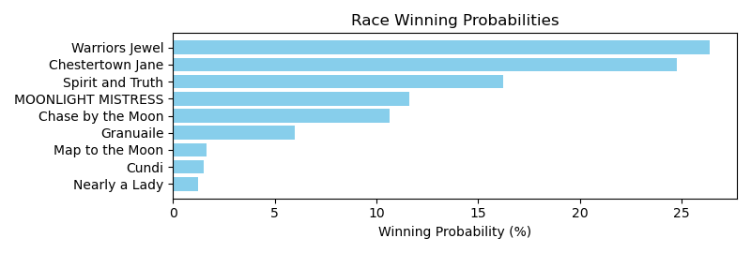

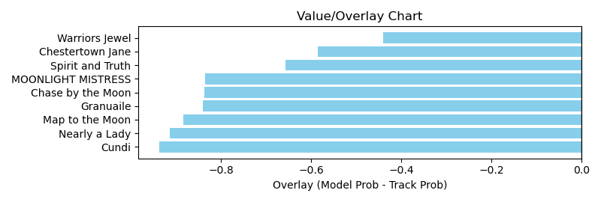

NOTE: GCSF - Global Combined Speed Figure

# Race: LRL | 2025-03-30 | Race #2 | Post: 12:36 | Track: LAUREL PARK

Track: LAUREL PARK

|  |  |  |  |  |  |
| --- | --- | --- | --- | --- | --- |
| Program # | Horse Name | Morn Odds | GCSF | Model Score | Win Prob (%) |
| 1 | Just for the Money | 8-1 | 94.5 | 0.66 | 0.86 |
| 2 | Tycoon Mogul | 7-2 | 106.6 | 1.42 | 25.26 |
| 3 | Aikmans Audible | 9-2 | 93.8 | 0.92 | 3.76 |
| 4 | Hello Sunshine | 10-1 | 107.8 | 1.15 | 10.12 |
| 5 | Artillery Gunnar | 13-8 | 89.8 | 1.62 | 44.77 |
| 6 | Sir Mick | 4-1 | 111.1 | 1.18 | 10.99 |
| 7 | Set for Life | 12-1 | 90.8 | 0.95 | 4.23 |

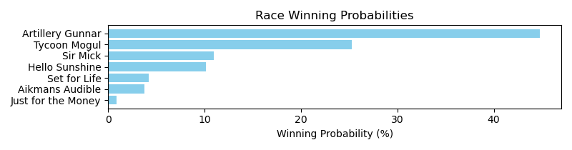

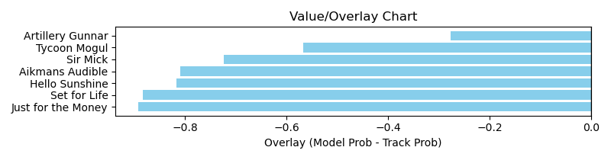

NOTE: GCSF - Global Combined Speed Figure

# Race: LRL | 2025-03-30 | Race #3 | Post: 13:03 | Track: LAUREL PARK

Track: LAUREL PARK

|  |  |  |  |  |  |
| --- | --- | --- | --- | --- | --- |
| Program # | Horse Name | Morn Odds | GCSF | Model Score | Win Prob (%) |
| 1 | Latin Rebel | 9-2 | 108.7 | 0.56 | 0.91 |
| 2 | REGENCY TALE | 4-1 | 100.0 | 1.17 | 22.35 |
| 3 | Dad Joke | 5-1 | 92.3 | 0.96 | 9.45 |
| 4 | Veneto | 1-1 | 106.7 | 1.33 | 39.02 |
| 5 | STRAIGHT TO WATER | 8-1 | 100.0 | 1.06 | 14.76 |
| 6 | Klimt Master | 30-1 | 93.1 | 0.52 | 0.62 |
| 7 | HANG ON KID | 12-1 | 100.0 | 1.03 | 12.88 |

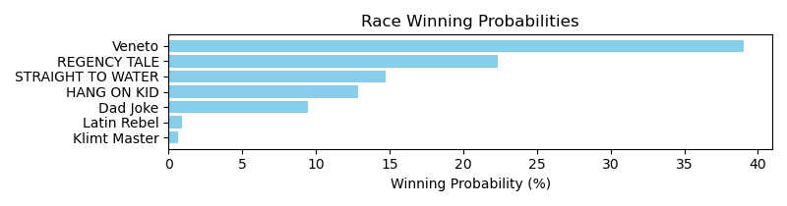

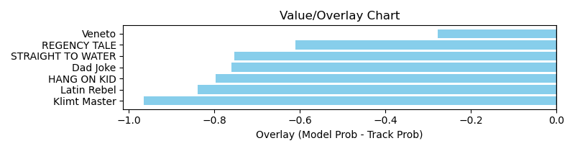

NOTE: GCSF - Global Combined Speed Figure

# Race: LRL | 2025-03-30 | Race #4 | Post: 13:32 | Track: LAUREL PARK

Track: LAUREL PARK

|  |  |  |  |  |  |
| --- | --- | --- | --- | --- | --- |
| Program # | Horse Name | Morn Odds | GCSF | Model Score | Win Prob (%) |
| 1 | Where's My Chew | 8-1 | 100.0 | 1.32 | 15.13 |
| 2 | Bangkok Bob | 3-1 | 93.4 | 1.31 | 14.66 |
| 3 | Slam Notion | 6-5 | 90.9 | 1.76 | 53.60 |
| 4 | Anlon | 15-1 | 100.0 | 1.23 | 10.93 |
| 5 | Missed the Turn | 10-1 | 92.4 | 0.92 | 3.11 |
| 6 | Tojo's Mojo | 5-2 | 106.6 | 0.88 | 2.57 |

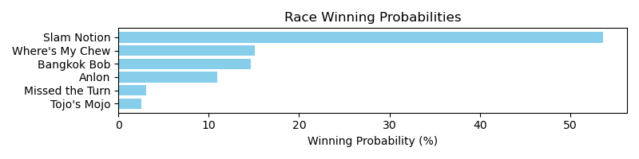

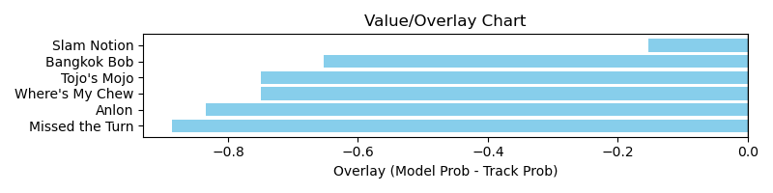

NOTE: GCSF - Global Combined Speed Figure

# Race: LRL | 2025-03-30 | Race #5 | Post: 14:03 | Track: LAUREL PARK

Track: LAUREL PARK

|  |  |  |  |  |  |
| --- | --- | --- | --- | --- | --- |
| Program # | Horse Name | Morn Odds | GCSF | Model Score | Win Prob (%) |
| 1 | Walk Away Joe | 2-1 | 99.6 | 1.34 | 24.74 |
| 1A | Berks | 2-1 | 98.5 | 1.25 | 18.16 |
| 2 | Formal Order | 10-1 | 104.0 | 0.98 | 6.35 |
| 3 | Southern District | 7-2 | 105.1 | 1.18 | 14.07 |
| 4 | Daredavite | 20-1 | 103.3 | 0.82 | 2.89 |
| 5 | Hornbeam | 5-2 | 96.7 | 0.99 | 6.54 |
| 6 | Rhumjar | 6-1 | 95.9 | 1.17 | 13.72 |
| 7 | Toast to Coast | 10-1 | 106.3 | 1.05 | 8.42 |
| 8 | Speargun | 12-1 | 95.7 | 0.93 | 5.10 |

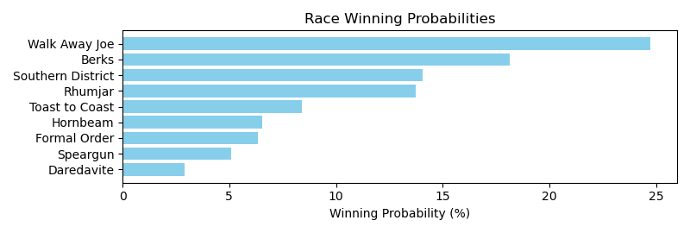

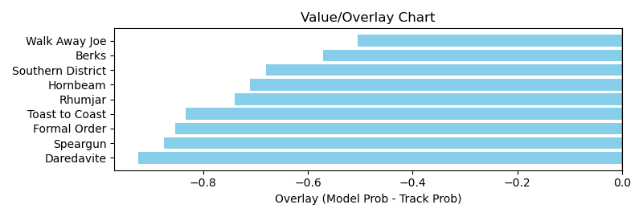

NOTE: GCSF - Global Combined Speed Figure

# Race: LRL | 2025-03-30 | Race #6 | Post: 14:35 | Track: LAUREL PARK

Track: LAUREL PARK

|  |  |  |  |  |  |
| --- | --- | --- | --- | --- | --- |
| Program # | Horse Name | Morn Odds | GCSF | Model Score | Win Prob (%) |
| 1 | Kitten's Appeal | 9-2 | 95.4 | 1.16 | 4.44 |
| 2 | Devil Pays in Gold | 2-1 | 102.1 | 1.89 | 37.38 |
| 3 | Stickwiththecolors | 9-5 | 94.8 | 1.98 | 46.41 |
| 4 | Angel Art | 10-1 | 94.0 | 1.05 | 2.83 |
| 5 | Winkiwinki | 8-1 | 107.1 | 0.95 | 1.82 |
| 6 | Talk to the Judge | 15-1 | 94.4 | 0.83 | 1.05 |
| 7 | Discreet Ops | 6-1 | 87.4 | 1.25 | 6.08 |

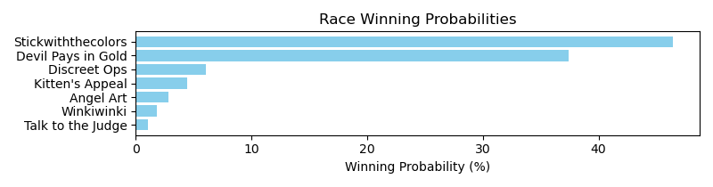

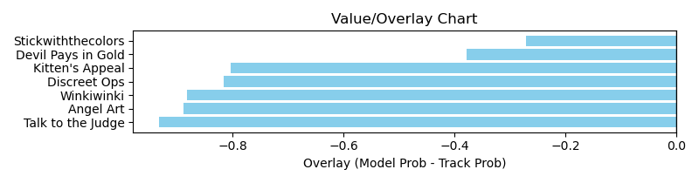

NOTE: GCSF - Global Combined Speed Figure

# Race: LRL | 2025-03-30 | Race #7 | Post: 15:06 | Track: LAUREL PARK

Track: LAUREL PARK

|  |  |  |  |  |  |
| --- | --- | --- | --- | --- | --- |
| Program # | Horse Name | Morn Odds | GCSF | Model Score | Win Prob (%) |
| 1 | Lady Zeta | 13-8 | 111.6 | 1.26 | 8.24 |
| 2 | Anonymously | 9-5 | 112.7 | 1.73 | 33.42 |
| 3 | Love to Eat | 5-1 | 102.4 | 1.03 | 3.39 |
| 4 | Always Forward | 20-1 | 89.7 | 0.78 | 1.05 |
| 5 | Waterloo Rose | 10-1 | 100.0 | 1.01 | 3.19 |
| 6 | Hateful | 9-2 | 99.3 | 1.14 | 5.35 |
| 7 | Bound by Destiny | 15-1 | 94.5 | 1.86 | 45.37 |

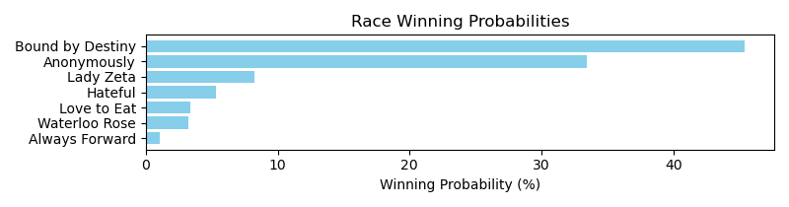

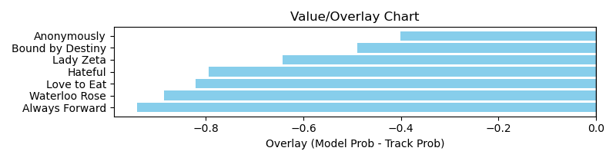

NOTE: GCSF - Global Combined Speed Figure

# Race: LRL | 2025-03-30 | Race #8 | Post: 15:40 | Track: LAUREL PARK

Track: LAUREL PARK

|  |  |  |  |  |  |
| --- | --- | --- | --- | --- | --- |
| Program # | Horse Name | Morn Odds | GCSF | Model Score | Win Prob (%) |
| 1 | THE GREATEST (ARG) | 12-1 | 100.0 | 0.86 | 10.83 |
| 2 | LE BLANC (ARG) | 8-1 | 100.0 | 0.87 | 11.03 |
| 3 | TIEMPO DE ESTAR (ARG) | 4-1 | 100.0 | 0.86 | 10.68 |
| 4 | SIMPATICO BOY (ARG) | 30-1 | 100.0 | 0.87 | 11.03 |
| 5 | CAPITAL BOSS (ARG) | 5-1 | 100.0 | 0.87 | 11.39 |
| 6 | POWER DETTO (ARG) | 30-1 | 100.0 | 0.89 | 12.58 |
| 7 | BOLERO FRANK (ARG) | 3-1 | 100.0 | 0.86 | 10.44 |
| 8 | HI POTTER (ARG) | 6-1 | 100.0 | 0.87 | 11.23 |
| 9 | CRISETTE (ARG) | 5-2 | 100.0 | 0.86 | 10.80 |

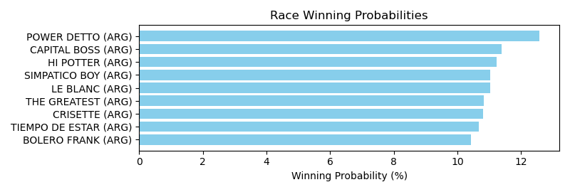

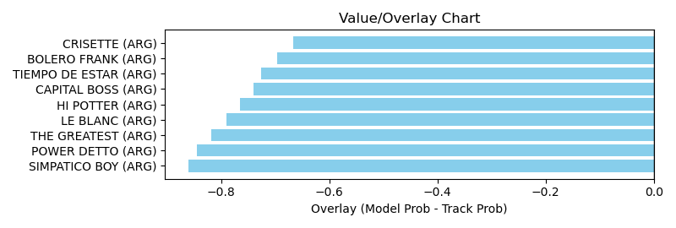

NOTE: GCSF - Global Combined Speed Figure

# Race: LRL | 2025-03-30 | Race #9 | Post: 16:10 | Track: LAUREL PARK

Track: LAUREL PARK

|  |  |  |  |  |  |
| --- | --- | --- | --- | --- | --- |
| Program # | Horse Name | Morn Odds | GCSF | Model Score | Win Prob (%) |
| 1 | TANGAZO MOI (ARG) | 30-1 | 100.0 | 0.86 | 9.81 |
| 2 | LE PURPLE (ARG) | 8-1 | 100.0 | 0.87 | 10.29 |
| 3 | WARHOL (ARG) | 15-1 | 100.0 | 0.91 | 12.73 |
| 4 | SHANIDAR (ARG) | 15-1 | 100.0 | 0.87 | 10.46 |
| 5 | DON ZAHIR (ARG) | 9-2 | 100.0 | 0.91 | 13.00 |
| 6 | SENOR DALTON (ARG) | 4-5 | 100.0 | 0.86 | 10.04 |
| 7 | BRAVO BRUNO (ARG) | 6-1 | 100.0 | 0.91 | 13.10 |
| 8 | ENGUALICHAO (ARG) | 10-1 | 100.0 | 0.86 | 10.25 |
| 9 | ELEGILO A EL (ARG) | 20-1 | 100.0 | 0.87 | 10.32 |

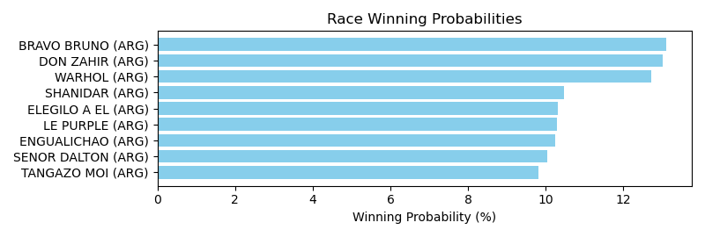

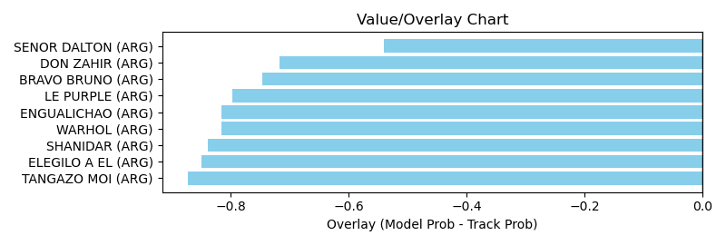

NOTE: GCSF - Global Combined Speed Figure

# Race: LRL | 2025-03-30 | Race #10 | Post: 16:40 | Track: LAUREL PARK

Track: LAUREL PARK

|  |  |  |  |  |  |
| --- | --- | --- | --- | --- | --- |
| Program # | Horse Name | Morn Odds | GCSF | Model Score | Win Prob (%) |
| 1 | VERENNA (ARG) | 4-1 | 100.0 | 0.95 | 12.55 |
| 2 | CHE MAMITA (ARG) | 8-1 | 100.0 | 0.88 | 9.22 |
| 3 | VIEJA AMIGA MASK (ARG) | 9-2 | 100.0 | 0.84 | 7.46 |
| 4 | UDINESE (BRZ) | 15-1 | 100.0 | 0.90 | 9.96 |
| 5 | CANDLELIT (ARG) | 12-1 | 100.0 | 0.94 | 12.06 |
| 6 | LOOK HAPPY (ARG) | 6-1 | 100.0 | 0.87 | 8.67 |
| 7 | AMIGUITA SONADA (ARG) | 20-1 | 100.0 | 0.92 | 11.27 |
| 8 | CHAMPION CRAF (ARG) | 15-1 | 100.0 | 0.94 | 12.12 |
| 9 | CASTELL QUEEN (ARG) | 7-1 | 100.0 | 0.88 | 9.20 |
| 10 | CONI FIZZ (ARG) | 3-1 | 100.0 | 0.84 | 7.48 |

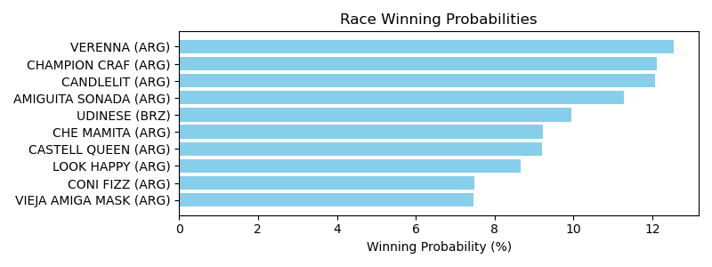

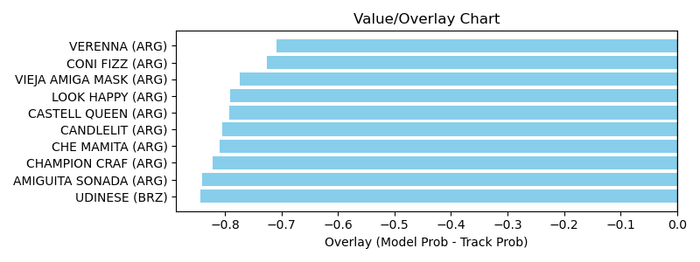

NOTE: GCSF - Global Combined Speed Figure

# Race: LRL | 2025-03-30 | Race #11 | Post: 17:10 | Track: LAUREL PARK

Track: LAUREL PARK

|  |  |  |  |  |  |
| --- | --- | --- | --- | --- | --- |
| Program # | Horse Name | Morn Odds | GCSF | Model Score | Win Prob (%) |
| 1 | LOVE ME PASS (ARG) | 5-1 | 100.0 | 0.89 | 12.13 |
| 2 | LA SENCILLEZ (ARG) | 4-1 | 100.0 | 0.90 | 12.34 |
| 3 | NUNCA SANTA (ARG) | 7-1 | 100.0 | 0.95 | 16.05 |
| 4 | LOGRADA BIEN (ARG) | 2-1 | 100.0 | 0.89 | 11.89 |
| 5 | JOY ANTUMALAL (ARG) | 50-1 | 100.0 | 0.87 | 10.88 |
| 6 | LADY PROUD (ARG) | 15-1 | 100.0 | 0.91 | 13.54 |
| 7 | GRAND BANKER (ARG) | 50-1 | 100.0 | 0.89 | 11.75 |
| 8 | KISS PAMPA (ARG) | 9-5 | 100.0 | 0.88 | 11.41 |

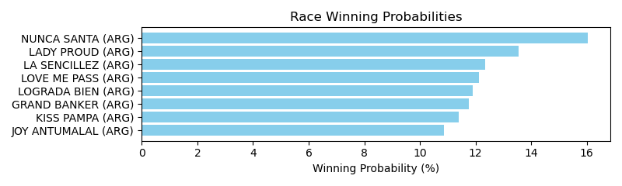

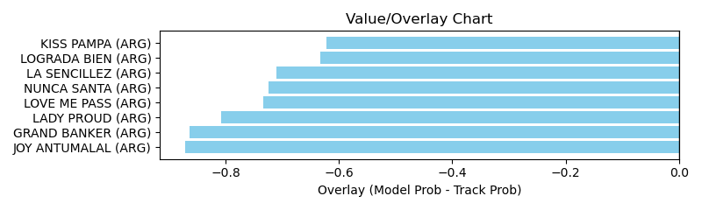

NOTE: GCSF - Global Combined Speed Figure

# Race: LRL | 2025-03-30 | Race #12 | Post: 17:40 | Track: LAUREL PARK

Track: LAUREL PARK

|  |  |  |  |  |  |
| --- | --- | --- | --- | --- | --- |
| Program # | Horse Name | Morn Odds | GCSF | Model Score | Win Prob (%) |
| 1 | TIO CHARO (ARG) | 5-1 | 100.0 | 0.87 | 13.42 |
| 2 | PEDES CLAUX (ARG) | 9-5 | 100.0 | 0.84 | 11.84 |
| 3 | WINDY STORM (ARG) | 2-1 | 100.0 | 0.84 | 11.38 |
| 4 | SEA SOUND (ARG) | 8-1 | 100.0 | 0.93 | 17.83 |
| 5 | KALMURIEL CAP (ARG) | 10-1 | 100.0 | 0.86 | 12.75 |
| 6 | PERSIAN ISLAND (ARG) | 12-1 | 100.0 | 0.90 | 16.08 |
| 7 | AIRE LUNAR (ARG) | 6-1 | 100.0 | 0.91 | 16.70 |

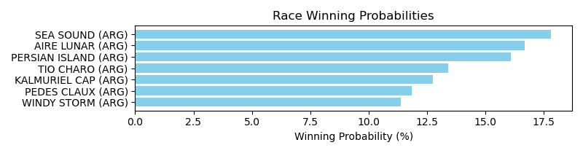

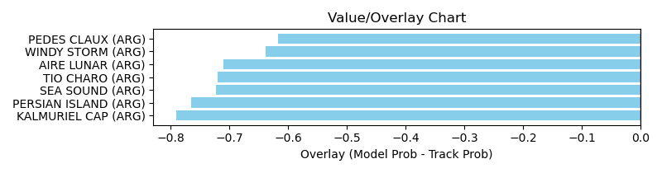

NOTE: GCSF - Global Combined Speed Figure

# Race: LRL | 2025-03-30 | Race #13 | Post: 18:10 | Track: LAUREL PARK

Track: LAUREL PARK

|  |  |  |  |  |  |
| --- | --- | --- | --- | --- | --- |
| Program # | Horse Name | Morn Odds | GCSF | Model Score | Win Prob (%) |
| 1 | MELODY FREE (ARG) | 50-1 | 100.0 | 0.90 | 10.67 |
| 2 | FUTURE GIRL (ARG) | 5-1 | 100.0 | 0.85 | 8.63 |
| 3 | QUEEN MEGAN (ARG) | 9-2 | 100.0 | 0.85 | 8.66 |
| 4 | MEHORA (ARG) | 7-1 | 100.0 | 0.92 | 12.17 |
| 5 | DONA TWISTER | 4-1 | 100.0 | 0.89 | 10.20 |
| 6 | INDYMANIA (ARG) | 20-1 | 100.0 | 0.89 | 10.39 |
| 7 | ANGELIC CHAMP (ARG) | 8-1 | 100.0 | 0.88 | 10.00 |
| 8 | ESCULLAT (ARG) | 30-1 | 100.0 | 0.89 | 10.56 |
| 9 | ES BELLISIMA (ARG) | 8-1 | 100.0 | 0.88 | 10.12 |
| 10 | HARLAN'S RIM (ARG) | 5-2 | 100.0 | 0.85 | 8.60 |

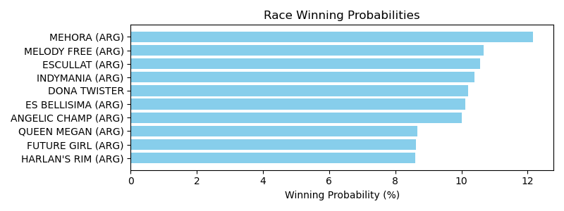

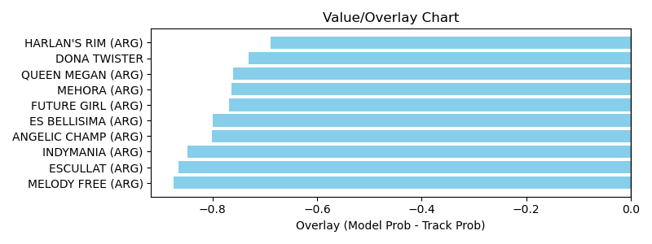

NOTE: GCSF - Global Combined Speed Figure

# Race: LRL | 2025-03-30 | Race #14 | Post: 18:40 | Track: LAUREL PARK

Track: LAUREL PARK

|  |  |  |  |  |  |
| --- | --- | --- | --- | --- | --- |
| Program # | Horse Name | Morn Odds | GCSF | Model Score | Win Prob (%) |
| 1 | SOL DE TORMENTA (ARG) | 5-1 | 100.0 | 0.91 | 10.14 |
| 2 | MR.CANONICO (ARG) | 5-2 | 100.0 | 0.90 | 9.60 |
| 3 | THE GUARDIAN (ARG) | 10-1 | 100.0 | 0.89 | 9.37 |
| 4 | SENOR GATO (ARG) | 30-1 | 100.0 | 0.84 | 7.23 |
| 5 | EL LUCERITO (ARG) | 20-1 | 100.0 | 0.87 | 8.14 |
| 6 | PRECIOUS MACHINE (ARG) | 50-1 | 100.0 | 0.84 | 7.20 |
| 7 | DON MARTIR (ARG) | 7-2 | 100.0 | 0.84 | 7.15 |
| 8 | JAY BEACH (ARG) | 8-1 | 100.0 | 0.89 | 9.28 |
| 9 | HAPPY CHAMP (ARG) | 7-1 | 100.0 | 0.94 | 11.63 |
| 10 | ONE THING (BRZ) | 9-2 | 100.0 | 0.91 | 9.90 |
| 11 | LIFESTYLER (ARG) | 50-1 | 100.0 | 0.92 | 10.37 |

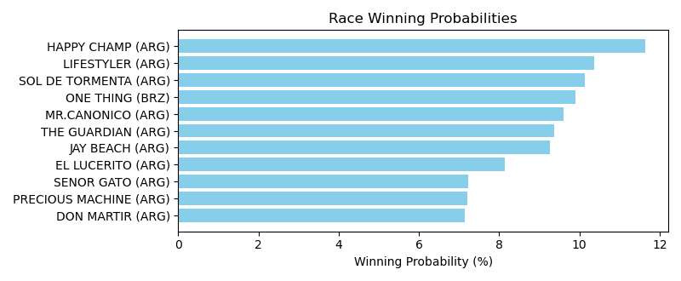

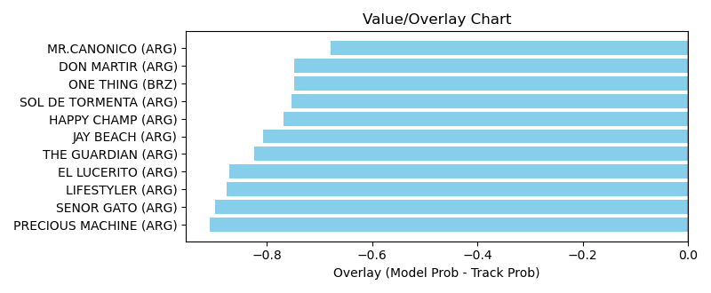

NOTE: GCSF - Global Combined Speed Figure

# Race: MVR | 2025-03-30 | Race #1 | Post: 12:15 | Track: MAHONING VALLEY RACE COURSE

Track: MAHONING VALLEY RACE COURSE

|  |  |  |  |  |  |
| --- | --- | --- | --- | --- | --- |
| Program # | Horse Name | Morn Odds | GCSF | Model Score | Win Prob (%) |
| 1 | Uncle's the Banker | 20-1 | 105.5 | 1.05 | 12.34 |
| 2 | One Red Cent | 4-1 | 100.2 | 0.85 | 4.84 |
| 3 | Notorious Sixohtwo | 5-2 | 94.6 | 1.26 | 26.40 |
| 4 | Zippin Gigi | 6-1 | 97.7 | 1.17 | 19.26 |
| 5 | Bailamos | 8-1 | 104.0 | 0.90 | 6.30 |
| 6 | Big Bucksalot | 6-5 | 98.9 | 1.30 | 30.86 |

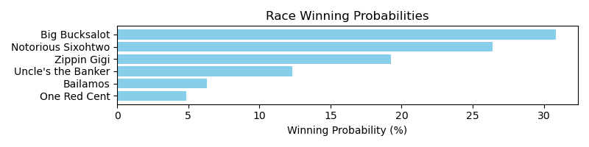

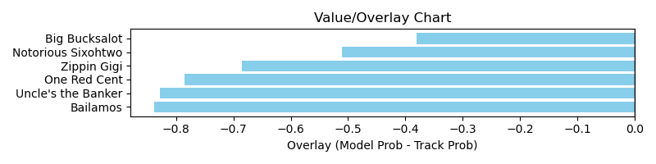

NOTE: GCSF - Global Combined Speed Figure

# Race: MVR | 2025-03-30 | Race #2 | Post: 12:43 | Track: MAHONING VALLEY RACE COURSE

Track: MAHONING VALLEY RACE COURSE

|  |  |  |  |  |  |
| --- | --- | --- | --- | --- | --- |
| Program # | Horse Name | Morn Odds | GCSF | Model Score | Win Prob (%) |
| 1 | Little Shance | 4-5 | 100.0 | 1.07 | 24.58 |
| 2 | JERICHO TRUMPET | 3-1 | 100.0 | 0.93 | 13.57 |
| 3 | HAPPYCASTLE | 15-1 | 100.0 | 0.87 | 10.22 |
| 4 | A Van On the Run | 4-1 | 100.0 | 1.02 | 20.54 |
| 5 | Mor Stormy | 15-1 | 100.0 | 0.94 | 13.80 |
| 6 | Runaway Power | 8-1 | 100.0 | 0.99 | 17.29 |

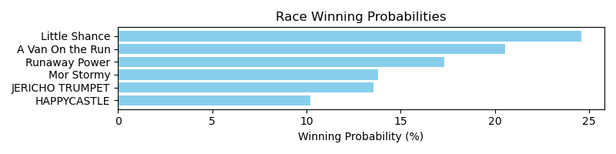

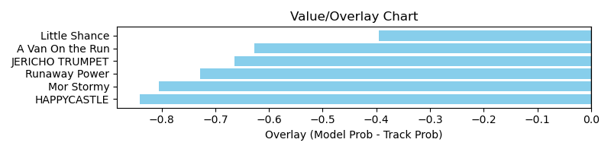

NOTE: GCSF - Global Combined Speed Figure

# Race: MVR | 2025-03-30 | Race #3 | Post: 13:11 | Track: MAHONING VALLEY RACE COURSE

Track: MAHONING VALLEY RACE COURSE

|  |  |  |  |  |  |
| --- | --- | --- | --- | --- | --- |
| Program # | Horse Name | Morn Odds | GCSF | Model Score | Win Prob (%) |
| 1 | Bad Little Beast | 20-1 | 99.3 | 0.80 | 3.03 |
| 2 | Broadway Jones | 20-1 | 100.0 | 1.28 | 24.03 |
| 3 | First Citizen | 12-1 | 115.0 | 1.14 | 14.55 |
| 4 | Call Me Gusto | 2-1 | 91.0 | 0.82 | 3.55 |
| 5 | Versatile | 9-2 | 93.7 | 1.11 | 13.02 |
| 6 | Richiesgotgame | 5-2 | 90.3 | 1.10 | 12.59 |
| 7 | Stealththirtyfour | 8-1 | 107.5 | 0.92 | 5.66 |
| 8 | Montauk Cove | 15-1 | 115.4 | 1.12 | 13.62 |
| 9 | The Coachman | 6-1 | 99.7 | 1.04 | 9.95 |

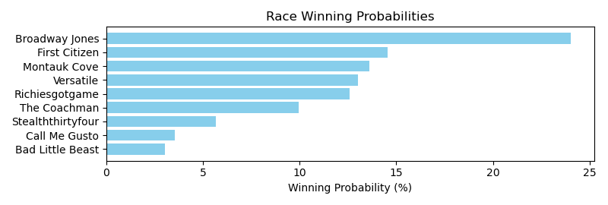

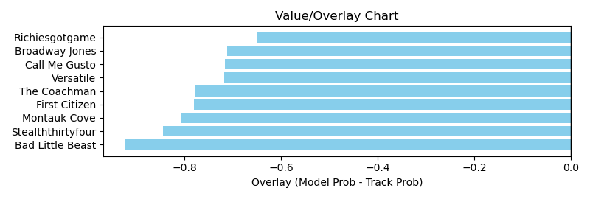

NOTE: GCSF - Global Combined Speed Figure

# Race: MVR | 2025-03-30 | Race #4 | Post: 13:39 | Track: MAHONING VALLEY RACE COURSE

Track: MAHONING VALLEY RACE COURSE

|  |  |  |  |  |  |
| --- | --- | --- | --- | --- | --- |
| Program # | Horse Name | Morn Odds | GCSF | Model Score | Win Prob (%) |
| 1 | American Hero | 3-1 | 102.7 | 1.02 | 10.12 |
| 2 | Torrefactor | 15-1 | 108.2 | 0.81 | 3.70 |
| 3 | Chaps Knight | 10-1 | 113.3 | 0.88 | 5.47 |
| 4 | Puff'smagicdragon | 2-1 | 109.2 | 1.39 | 39.35 |
| 5 | Arrebato | 4-1 | 94.7 | 1.13 | 15.90 |
| 6 | Ramsey | 5-2 | 102.5 | 1.20 | 21.15 |
| 7 | Color Me Legendary | 20-1 | 102.0 | 0.84 | 4.31 |

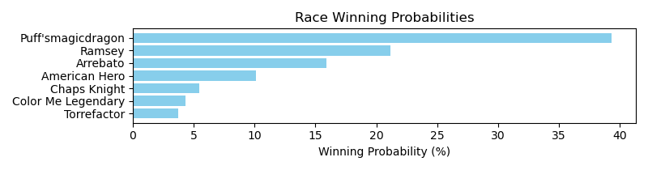

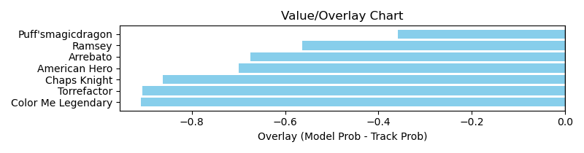

NOTE: GCSF - Global Combined Speed Figure

# Race: MVR | 2025-03-30 | Race #5 | Post: 14:07 | Track: MAHONING VALLEY RACE COURSE

Track: MAHONING VALLEY RACE COURSE

|  |  |  |  |  |  |
| --- | --- | --- | --- | --- | --- |
| Program # | Horse Name | Morn Odds | GCSF | Model Score | Win Prob (%) |
| 1 | Elliot the Dragon | 2-1 | 97.8 | 1.82 | 48.22 |
| 2 | Uptown | 6-1 | 98.9 | 1.27 | 9.96 |
| 3 | Mister Mobil | 9-2 | 97.3 | 1.00 | 3.51 |
| 4 | Hite | 10-1 | 86.7 | 1.04 | 4.17 |
| 5 | Quiet Amigo | 12-1 | 110.6 | 1.16 | 6.68 |
| 6 | It'sgoodtobeseen | 15-1 | 113.4 | 0.89 | 2.14 |
| 7 | Biscuits and Grits | 10-1 | 111.7 | 1.10 | 5.31 |
| 8 | Liberate | 3-1 | 100.0 | 1.40 | 15.39 |
| 9 | Red Head Kid | 15-1 | 110.5 | 1.06 | 4.61 |

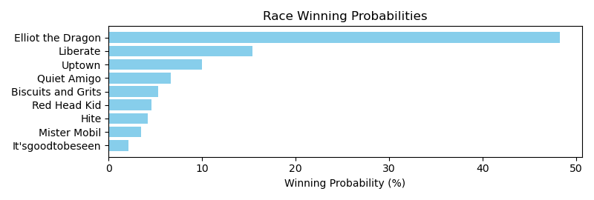

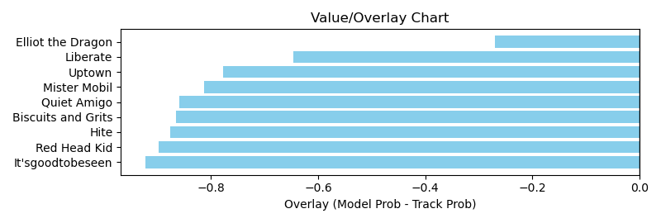

NOTE: GCSF - Global Combined Speed Figure

# Race: MVR | 2025-03-30 | Race #6 | Post: 14:35 | Track: MAHONING VALLEY RACE COURSE

Track: MAHONING VALLEY RACE COURSE

|  |  |  |  |  |  |
| --- | --- | --- | --- | --- | --- |
| Program # | Horse Name | Morn Odds | GCSF | Model Score | Win Prob (%) |
| 1 | Devra Warrior | 10-1 | 93.7 | 0.81 | 5.46 |
| 2 | Kaiyas Song | 6-1 | 112.7 | 0.99 | 12.99 |
| 3 | Redwhiteandtacos | 4-1 | 96.2 | 1.03 | 15.66 |
| 4 | Battle Tested | 7-2 | 91.1 | 1.14 | 23.97 |
| 5 | Torrey Street | 5-1 | 106.8 | 1.17 | 26.86 |
| 6 | Just Stay Home | 9-2 | 90.6 | 0.85 | 6.87 |
| 7 | Sacred Connection | 3-1 | 91.9 | 0.89 | 8.19 |

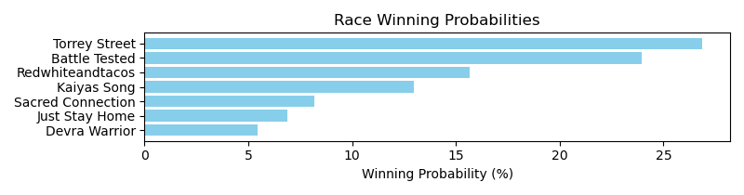

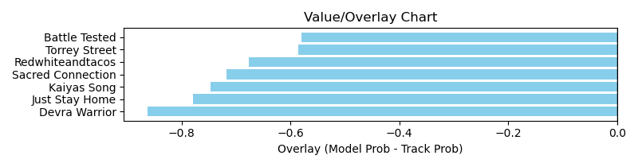

NOTE: GCSF - Global Combined Speed Figure

# Race: MVR | 2025-03-30 | Race #7 | Post: 15:03 | Track: MAHONING VALLEY RACE COURSE

Track: MAHONING VALLEY RACE COURSE

|  |  |  |  |  |  |
| --- | --- | --- | --- | --- | --- |
| Program # | Horse Name | Morn Odds | GCSF | Model Score | Win Prob (%) |
| 1 | Boogie Boogee | 3-1 | 101.6 | 1.27 | 15.64 |
| 2 | Quick Rendezvous | 6-1 | 100.0 | 1.04 | 6.62 |
| 3 | Mobil Memory | 9-2 | 107.3 | 1.46 | 28.82 |
| 4 | Lexy Anna | 5-1 | 100.0 | 1.20 | 12.25 |
| 5 | Lofty Cowtown | 7-2 | 100.0 | 1.29 | 16.93 |
| 6 | Kichi Kitsu | 5-2 | 96.2 | 1.34 | 19.75 |

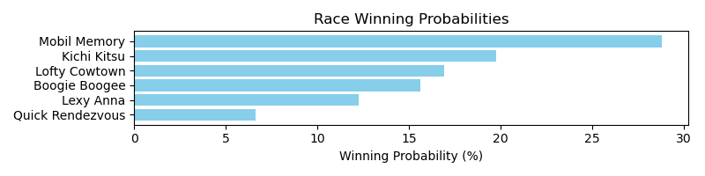

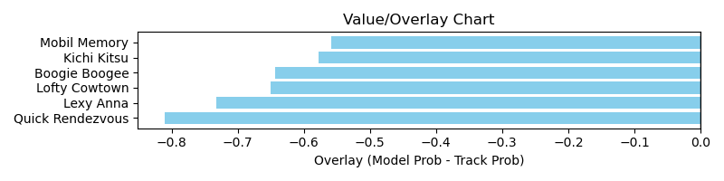

NOTE: GCSF - Global Combined Speed Figure

# Race: MVR | 2025-03-30 | Race #8 | Post: 15:31 | Track: MAHONING VALLEY RACE COURSE

Track: MAHONING VALLEY RACE COURSE

|  |  |  |  |  |  |
| --- | --- | --- | --- | --- | --- |
| Program # | Horse Name | Morn Odds | GCSF | Model Score | Win Prob (%) |
| 1 | Mrs Chofis | 12-1 | 97.5 | 0.72 | 1.67 |
| 2 | Solo Surprise | 10-1 | 100.0 | 1.08 | 9.51 |
| 3 | CREATOR OF MAGIC | 7-2 | 100.0 | 1.24 | 17.90 |
| 4 | Miss Little Bit | 20-1 | 100.0 | 1.01 | 7.20 |
| 5 | Explosive Lady | 5-2 | 93.4 | 1.13 | 12.02 |
| 6 | Orgullosa Pacifica | 20-1 | 100.0 | 1.01 | 7.25 |
| 7 | Aurora's Music | 6-1 | 89.7 | 0.95 | 5.61 |
| 8 | Lovebug | 3-1 | 99.0 | 1.25 | 18.34 |
| 9 | I Love Presents | 8-1 | 100.0 | 1.28 | 20.50 |

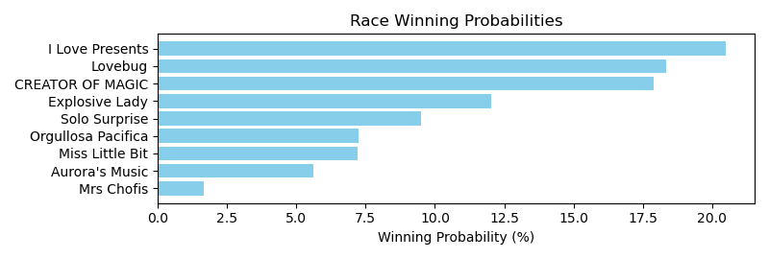

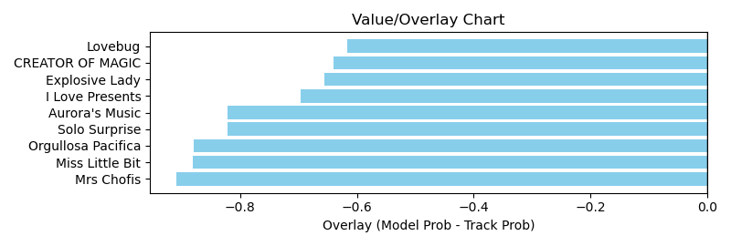

NOTE: GCSF - Global Combined Speed Figure

# Race: MVR | 2025-03-31 | Race #1 | Post: 12:15 | Track: MAHONING VALLEY RACE COURSE

Track: MAHONING VALLEY RACE COURSE

|  |  |  |  |  |  |
| --- | --- | --- | --- | --- | --- |
| Program # | Horse Name | Morn Odds | GCSF | Model Score | Win Prob (%) |
| 1 | Blazing Zenna | 20-1 | 93.7 | 0.98 | 6.56 |
| 2 | Secret Seduction | 8-1 | 100.0 | 1.24 | 17.85 |
| 3 | Girl Bye | 5-2 | 121.1 | 1.55 | 47.43 |
| 4 | Big Java | 15-1 | 94.2 | 0.96 | 6.05 |
| 5 | Hot Carol | 5-1 | 111.0 | 1.07 | 9.40 |
| 6 | Constitutionalist | 4-5 | 91.7 | 1.14 | 12.71 |

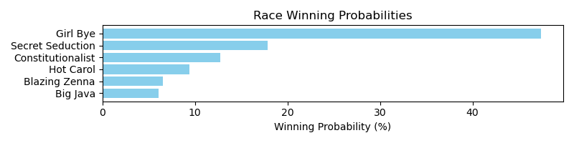

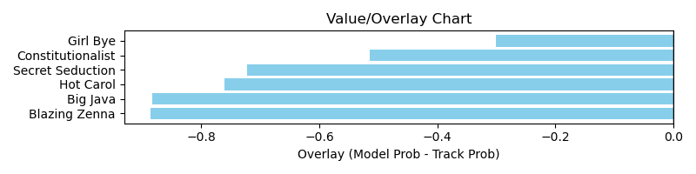

NOTE: GCSF - Global Combined Speed Figure

# Race: MVR | 2025-03-31 | Race #2 | Post: 12:43 | Track: MAHONING VALLEY RACE COURSE

Track: MAHONING VALLEY RACE COURSE

|  |  |  |  |  |  |
| --- | --- | --- | --- | --- | --- |
| Program # | Horse Name | Morn Odds | GCSF | Model Score | Win Prob (%) |
| 1 | Scratchoff | 6-1 | 109.9 | 1.19 | 23.68 |
| 2 | dq-Monterey Peninsula | 4-5 | 103.6 | 1.26 | 30.73 |
| 3 | Jareth | 5-1 | 90.0 | 1.03 | 12.93 |
| 4 | Kosciuszko | 6-1 | 113.5 | 0.96 | 9.13 |
| 5 | Nosey Power | 20-1 | 88.6 | 0.85 | 5.55 |
| 6 | Charger | 7-2 | 98.2 | 1.12 | 17.99 |

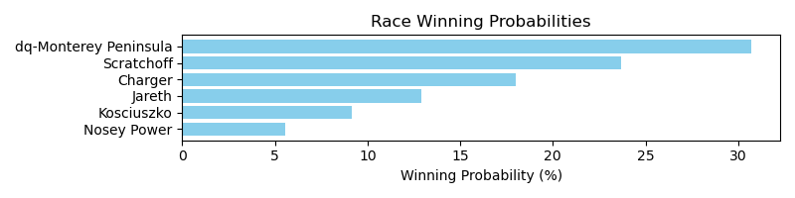

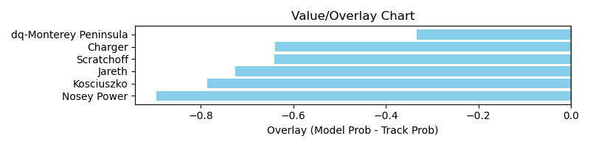

NOTE: GCSF - Global Combined Speed Figure

# Race: MVR | 2025-03-31 | Race #3 | Post: 13:11 | Track: MAHONING VALLEY RACE COURSE

Track: MAHONING VALLEY RACE COURSE

|  |  |  |  |  |  |
| --- | --- | --- | --- | --- | --- |
| Program # | Horse Name | Morn Odds | GCSF | Model Score | Win Prob (%) |
| 1 | Daisy Jones | 7-2 | 102.6 | 0.88 | 8.61 |
| 2 | Dame Straight | 2-1 | 101.3 | 1.05 | 18.77 |
| 3 | Athena's Ghost | 3-1 | 100.0 | 1.11 | 23.87 |
| 4 | Gran Conquistadora | 15-1 | 91.4 | 0.62 | 1.88 |
| 5 | Perfect Hour | 15-1 | 100.0 | 0.99 | 14.11 |
| 6 | Freedom Princess | 6-1 | 99.0 | 0.85 | 7.20 |
| 7 | Gran Roxy | 9-2 | 100.0 | 1.13 | 25.56 |

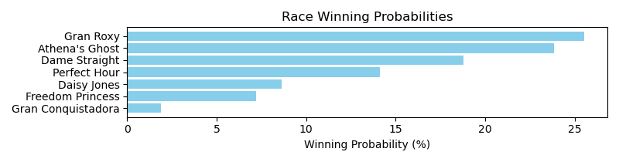

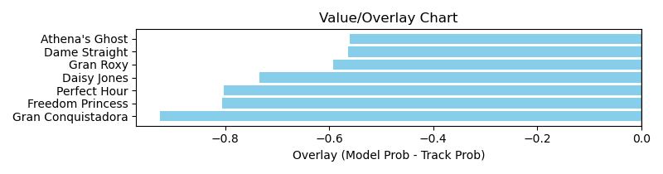

NOTE: GCSF - Global Combined Speed Figure

# Race: MVR | 2025-03-31 | Race #4 | Post: 13:39 | Track: MAHONING VALLEY RACE COURSE

Track: MAHONING VALLEY RACE COURSE

|  |  |  |  |  |  |
| --- | --- | --- | --- | --- | --- |
| Program # | Horse Name | Morn Odds | GCSF | Model Score | Win Prob (%) |
| 1 | Yehawmemaw | 15-1 | 100.0 | 1.08 | 12.42 |
| 2 | Beatiful Karla | 3-1 | 101.2 | 1.07 | 11.82 |
| 3 | Grace and Glory | 7-2 | 105.8 | 1.00 | 8.77 |
| 4 | Alter the Stars | 12-1 | 99.8 | 0.83 | 3.97 |
| 5 | Pacific View | 2-1 | 92.3 | 1.10 | 13.32 |
| 6 | Kantbackoff | 9-2 | 101.6 | 1.05 | 11.27 |
| 7 | Living in Style | 6-1 | 99.6 | 1.40 | 38.43 |

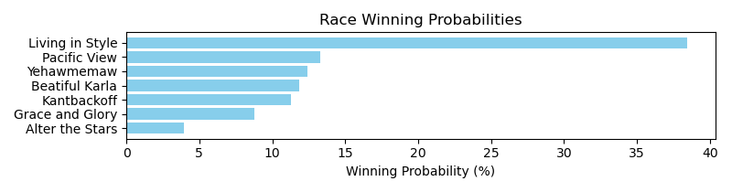

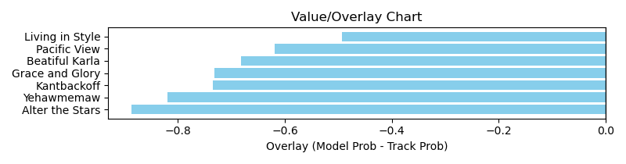

NOTE: GCSF - Global Combined Speed Figure

# Race: MVR | 2025-03-31 | Race #5 | Post: 14:07 | Track: MAHONING VALLEY RACE COURSE

Track: MAHONING VALLEY RACE COURSE

|  |  |  |  |  |  |
| --- | --- | --- | --- | --- | --- |
| Program # | Horse Name | Morn Odds | GCSF | Model Score | Win Prob (%) |
| 1 | Specialized | 5-2 | 100.0 | 1.39 | 18.59 |
| 2 | Dark Vader | 2-1 | 96.8 | 1.02 | 4.80 |
| 3 | Tammy's Toy | 20-1 | 120.5 | 0.85 | 2.14 |
| 4 | Scrimper | 6-1 | 100.0 | 1.30 | 13.97 |
| 5 | Lucky Streak | 8-1 | 101.5 | 1.18 | 9.24 |
| 6 | McGraw | 10-1 | 100.0 | 1.18 | 9.00 |
| 7 | Into Gold | 12-1 | 97.3 | 1.32 | 15.10 |
| 8 | Oaks Honey | 4-1 | 90.0 | 1.51 | 27.16 |

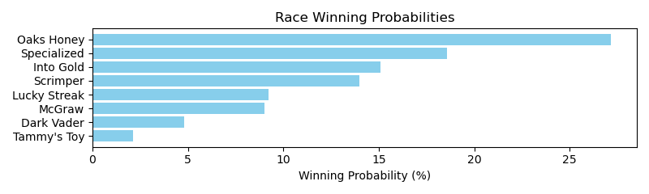

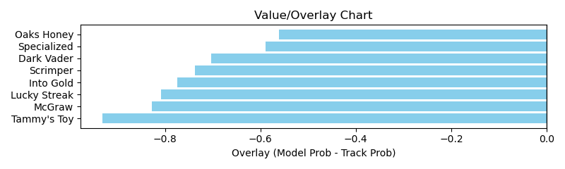

NOTE: GCSF - Global Combined Speed Figure

# Race: MVR | 2025-03-31 | Race #6 | Post: 14:35 | Track: MAHONING VALLEY RACE COURSE

Track: MAHONING VALLEY RACE COURSE

|  |  |  |  |  |  |
| --- | --- | --- | --- | --- | --- |
| Program # | Horse Name | Morn Odds | GCSF | Model Score | Win Prob (%) |
| 1 | Zakaria | 7-2 | 106.6 | 1.20 | 6.77 |
| 2 | Mister Mobil | 5-1 | 97.6 | 1.01 | 3.13 |
| 3 | Dr. Zarnett | 3-1 | 97.5 | 0.99 | 2.85 |
| 4 | First Song | 9-2 | 106.6 | 0.85 | 1.49 |
| 5 | Gottomakeithappen | 6-1 | 100.0 | 1.06 | 3.91 |
| 6 | Oklahoma Joe | 5-2 | 109.0 | 2.13 | 81.85 |

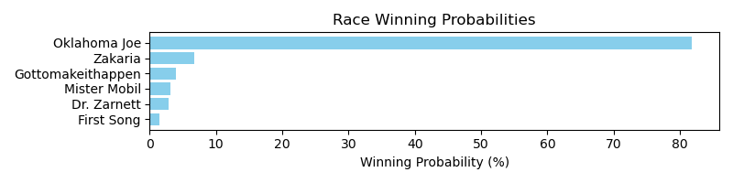

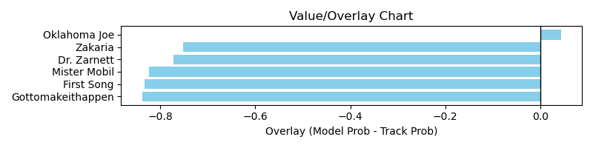

NOTE: GCSF - Global Combined Speed Figure

# Race: MVR | 2025-03-31 | Race #7 | Post: 15:03 | Track: MAHONING VALLEY RACE COURSE

Track: MAHONING VALLEY RACE COURSE

|  |  |  |  |  |  |
| --- | --- | --- | --- | --- | --- |
| Program # | Horse Name | Morn Odds | GCSF | Model Score | Win Prob (%) |
| 1 | Hot Princess | 6-1 | 100.0 | 0.97 | 6.37 |
| 2 | Flame for Real | 2-1 | 100.0 | 1.43 | 35.44 |
| 3 | Amy's Star | 13-8 | 100.0 | 1.37 | 29.28 |
| 4 | Beautiful Score | 10-1 | 100.0 | 1.11 | 11.68 |
| 5 | Praise N Glory | 5-2 | 100.0 | 1.21 | 17.23 |

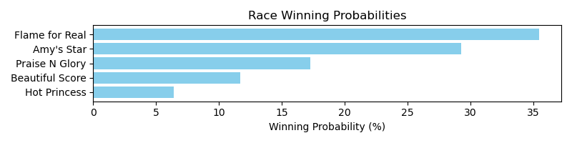

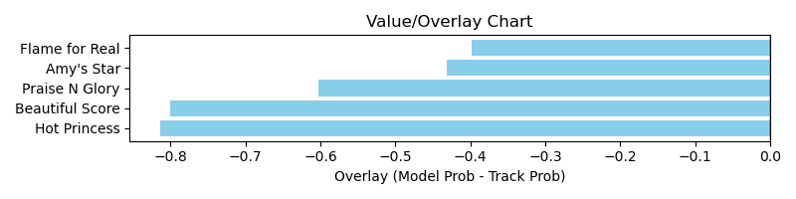

NOTE: GCSF - Global Combined Speed Figure

# Race: MVR | 2025-03-31 | Race #8 | Post: 15:31 | Track: MAHONING VALLEY RACE COURSE

Track: MAHONING VALLEY RACE COURSE

|  |  |  |  |  |  |
| --- | --- | --- | --- | --- | --- |
| Program # | Horse Name | Morn Odds | GCSF | Model Score | Win Prob (%) |
| 1 | Banana Pudding | 5-2 | 100.0 | 1.36 | 26.84 |
| 2 | Mima Princess | 20-1 | 100.0 | 0.90 | 4.49 |
| 3 | Shez Shacked Up | 6-1 | 100.0 | 1.19 | 15.19 |
| 4 | Oopsie Doopsie | 8-1 | 103.0 | 1.16 | 13.62 |
| 5 | Je Suis Rapide | 3-1 | 94.7 | 1.19 | 15.05 |
| 6 | Mission Girl | 7-2 | 94.7 | 1.26 | 19.10 |
| 7 | Ashlee's Ring | 4-1 | 95.2 | 0.95 | 5.71 |

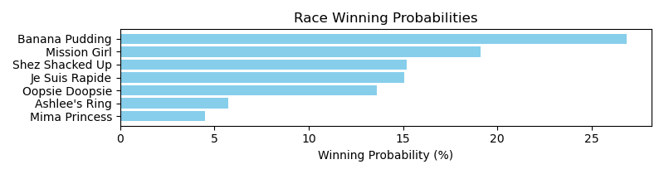

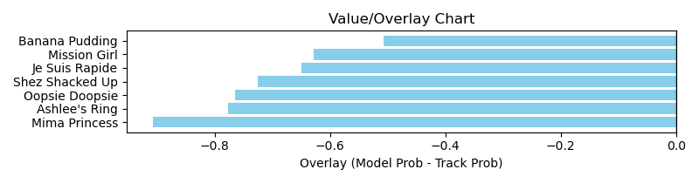

NOTE: GCSF - Global Combined Speed Figure

# Race: MVR | 2025-04-01 | Race #1 | Post: 12:15 | Track: MAHONING VALLEY RACE COURSE

Track: MAHONING VALLEY RACE COURSE

|  |  |  |  |  |  |
| --- | --- | --- | --- | --- | --- |
| Program # | Horse Name | Morn Odds | GCSF | Model Score | Win Prob (%) |
| 1 | Thisisridiculous | 5-1 | 101.2 | 0.96 | 8.24 |
| 2 | Tearaway Tom | 13-8 | 100.0 | 1.23 | 23.80 |
| 3 | Breeze the Bayou | 2-1 | 92.3 | 1.12 | 16.05 |
| 4 | Twice Shy | 4-1 | 100.0 | 1.23 | 23.65 |
| 5 | Dixie Man | 10-1 | 100.0 | 1.12 | 15.85 |
| 6 | Great Revelation | 12-1 | 100.0 | 1.06 | 12.41 |

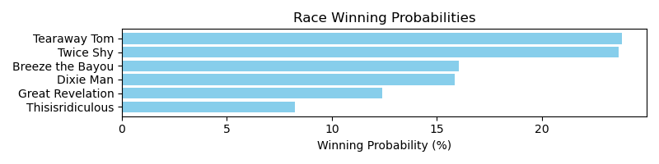

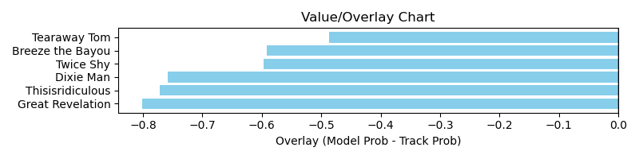

NOTE: GCSF - Global Combined Speed Figure

# Race: MVR | 2025-04-01 | Race #2 | Post: 12:43 | Track: MAHONING VALLEY RACE COURSE

Track: MAHONING VALLEY RACE COURSE

|  |  |  |  |  |  |
| --- | --- | --- | --- | --- | --- |
| Program # | Horse Name | Morn Odds | GCSF | Model Score | Win Prob (%) |
| 1 | Candymonium | 9-2 | 89.6 | 1.19 | 22.46 |
| 2 | Gracie Dance | 8-1 | 91.3 | 0.84 | 5.07 |
| 3 | May Mays Castle | 20-1 | 100.0 | 0.99 | 10.40 |
| 4 | Goldeneye Magic | 5-8 | 100.0 | 1.46 | 55.99 |
| 5 | Sharp Az Can Be | 3-1 | 93.4 | 0.88 | 6.09 |

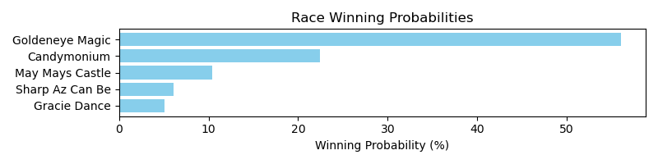

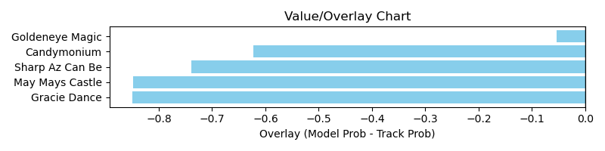

NOTE: GCSF - Global Combined Speed Figure

# Race: MVR | 2025-04-01 | Race #3 | Post: 13:11 | Track: MAHONING VALLEY RACE COURSE

Track: MAHONING VALLEY RACE COURSE

|  |  |  |  |  |  |
| --- | --- | --- | --- | --- | --- |
| Program # | Horse Name | Morn Odds | GCSF | Model Score | Win Prob (%) |
| 1 | Sheza Said Goodbye | 10-1 | 100.0 | 1.00 | 17.30 |
| 2 | Ocho's Secret | 3-1 | 100.0 | 0.92 | 11.96 |
| 3 | Loveumom | 9-2 | 100.0 | 1.13 | 29.81 |
| 4 | Nothing But Time | 6-1 | 113.0 | 0.71 | 3.92 |
| 5 | Wiz the Bomb | 5-1 | 106.6 | 0.90 | 10.82 |
| 6 | Red Delicious | 15-1 | 89.0 | 0.71 | 3.75 |
| 7 | Miss Athletic | 9-5 | 118.4 | 1.06 | 22.44 |

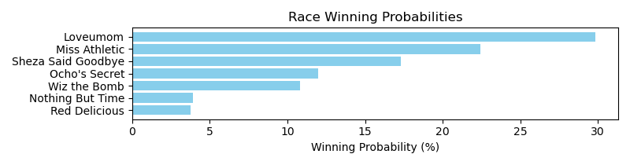

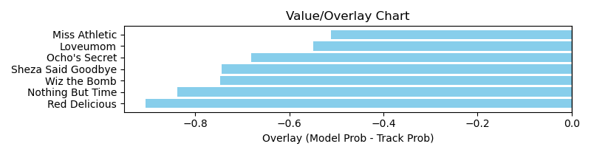

NOTE: GCSF - Global Combined Speed Figure

# Race: MVR | 2025-04-01 | Race #4 | Post: 13:39 | Track: MAHONING VALLEY RACE COURSE

Track: MAHONING VALLEY RACE COURSE

|  |  |  |  |  |  |
| --- | --- | --- | --- | --- | --- |
| Program # | Horse Name | Morn Odds | GCSF | Model Score | Win Prob (%) |
| 1 | Magic Palace | 12-1 | 82.8 | 0.87 | 4.57 |
| 2 | Yoga Queen | 5-1 | 95.9 | 1.00 | 8.10 |
| 3 | Honey Bella | 9-5 | 98.7 | 1.28 | 24.05 |
| 4 | Loaded Once More | 13-8 | 97.3 | 1.44 | 41.18 |
| 5 | Larimar | 3-1 | 111.3 | 1.25 | 22.10 |

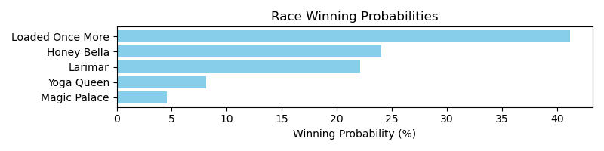

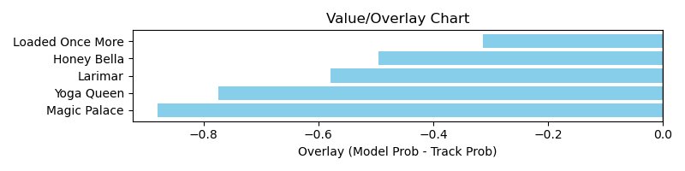

NOTE: GCSF - Global Combined Speed Figure

# Race: MVR | 2025-04-01 | Race #5 | Post: 14:07 | Track: MAHONING VALLEY RACE COURSE

Track: MAHONING VALLEY RACE COURSE

|  |  |  |  |  |  |
| --- | --- | --- | --- | --- | --- |
| Program # | Horse Name | Morn Odds | GCSF | Model Score | Win Prob (%) |
| 1 | Richiesgotgame | 6-5 | 101.1 | 1.20 | 20.53 |
| 2 | Candy Invasion | 7-2 | 100.0 | 1.36 | 34.86 |
| 3 | Klaatu | 15-1 | 104.5 | 0.97 | 7.92 |
| 4 | Milano | 3-1 | 106.3 | 0.94 | 7.11 |
| 5 | Monster Hunter | 10-1 | 112.7 | 0.97 | 8.14 |
| 6 | Krug | 8-1 | 97.7 | 1.12 | 14.74 |
| 7 | Delta Ridge | 12-1 | 93.8 | 0.93 | 6.70 |

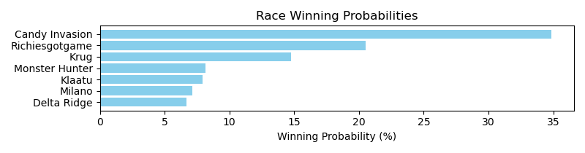

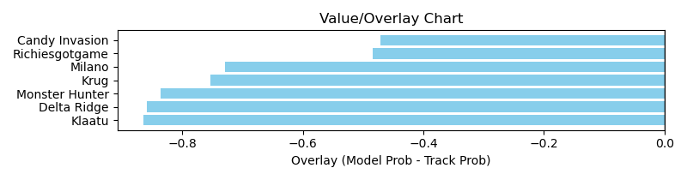

NOTE: GCSF - Global Combined Speed Figure

# Race: MVR | 2025-04-01 | Race #6 | Post: 14:35 | Track: MAHONING VALLEY RACE COURSE

Track: MAHONING VALLEY RACE COURSE

|  |  |  |  |  |  |
| --- | --- | --- | --- | --- | --- |
| Program # | Horse Name | Morn Odds | GCSF | Model Score | Win Prob (%) |
| 1 | Sage Runner | 10-1 | 94.9 | 0.87 | 7.35 |
| 2 | Capture Mi | 5-1 | 102.9 | 0.89 | 7.91 |
| 3 | Time the Avenger | 3-1 | 96.2 | 1.18 | 27.51 |
| 4 | Don't Stop | 2-1 | 99.3 | 1.08 | 19.01 |
| 5 | Run for Reagan | 5-2 | 94.7 | 1.08 | 18.45 |
| 6 | A Bit of Captain | 8-1 | 106.7 | 1.00 | 13.16 |
| 7 | Mexitexafornia | 12-1 | 100.0 | 0.85 | 6.62 |

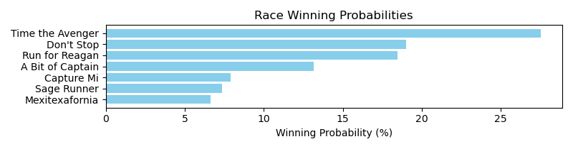

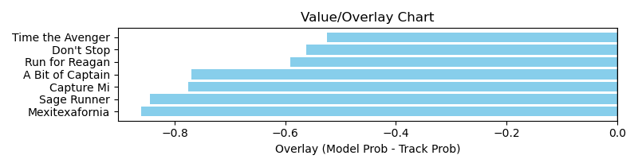

NOTE: GCSF - Global Combined Speed Figure

# Race: MVR | 2025-04-01 | Race #7 | Post: 15:03 | Track: MAHONING VALLEY RACE COURSE

Track: MAHONING VALLEY RACE COURSE

|  |  |  |  |  |  |
| --- | --- | --- | --- | --- | --- |
| Program # | Horse Name | Morn Odds | GCSF | Model Score | Win Prob (%) |
| 1 | Big Rowdy Dan | 7-2 | 102.2 | 1.15 | 17.40 |
| 2 | Making Me Crazy | 6-1 | 99.8 | 1.10 | 14.47 |
| 3 | Blue Max | 2-1 | 103.7 | 1.16 | 18.24 |
| 4 | Logico | 9-5 | 90.2 | 1.17 | 18.90 |
| 5 | Collectorate | 10-1 | 93.4 | 0.74 | 2.59 |
| 6 | Poker Partner | 8-1 | 100.0 | 1.28 | 28.40 |

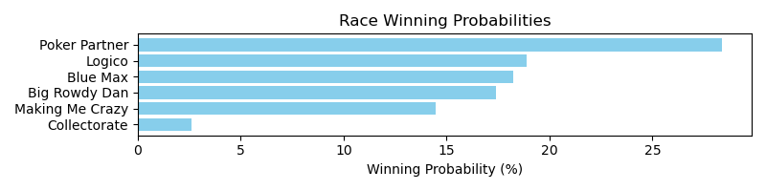

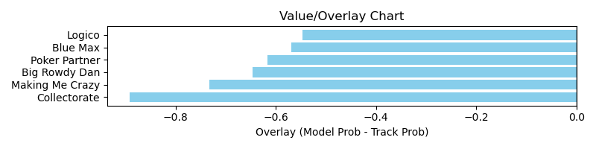

NOTE: GCSF - Global Combined Speed Figure

# Race: MVR | 2025-04-01 | Race #8 | Post: 15:31 | Track: MAHONING VALLEY RACE COURSE

Track: MAHONING VALLEY RACE COURSE

|  |  |  |  |  |  |
| --- | --- | --- | --- | --- | --- |
| Program # | Horse Name | Morn Odds | GCSF | Model Score | Win Prob (%) |
| 1 | Swing State | 3-1 | 107.8 | 1.04 | 4.80 |
| 2 | Falk | 8-1 | 96.3 | 1.07 | 5.53 |
| 3 | Kinderhook | 5-2 | 100.0 | 1.55 | 28.08 |
| 4 | Frosty Paws | 4-1 | 97.9 | 0.93 | 2.96 |
| 5 | Sammy and Shorty | 7-2 | 106.6 | 1.14 | 7.28 |
| 6 | Media Darling | 5-1 | 107.2 | 1.78 | 51.34 |

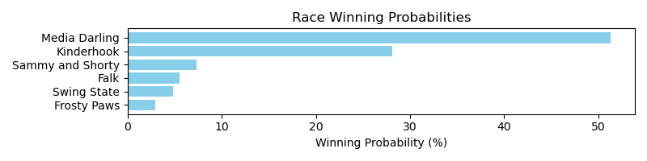

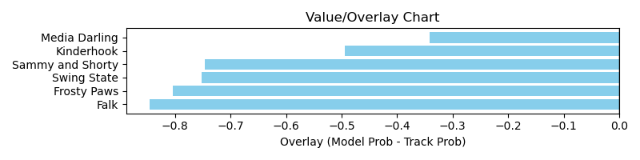

NOTE: GCSF - Global Combined Speed Figure

# Race: TOP | 2025-03-30 | Race #1 | Post: 12:35 | Track: OAKLAWN PARK

Track: OAKLAWN PARK

|  |  |  |  |  |  |
| --- | --- | --- | --- | --- | --- |
| Program # | Horse Name | Morn Odds | GCSF | Model Score | Win Prob (%) |
| 1 | Lilly Mae | 20-1 | 93.4 | 0.60 | 0.79 |
| 2 | Maxie Lady | 12-1 | 100.0 | 0.97 | 6.35 |
| 3 | Commander Dixie | 9-5 | 100.0 | 1.21 | 16.69 |
| 4 | CLEVER CLEMENTINE | 8-1 | 100.0 | 1.09 | 10.55 |
| 5 | VICKIE'S HALO | 30-1 | 100.0 | 1.05 | 8.67 |
| 6 | Joyful Josephine | 15-1 | 106.6 | 0.56 | 0.56 |
| 7 | Now We Go | 10-1 | 100.0 | 1.34 | 25.78 |
| 8 | No More Shots | 10-1 | 100.0 | 1.07 | 9.58 |
| 9 | Miss Makenna | 8-1 | 93.4 | 0.88 | 4.05 |
| 10 | Pickmeupatmidnight | 30-1 | 93.4 | 0.67 | 1.26 |
| 11 | Coventina | 12-1 | 100.0 | 1.14 | 12.77 |
| 12 | La Dinamita | 7-2 | 104.7 | 0.82 | 2.95 |

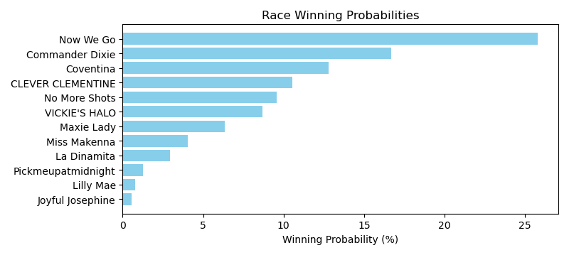

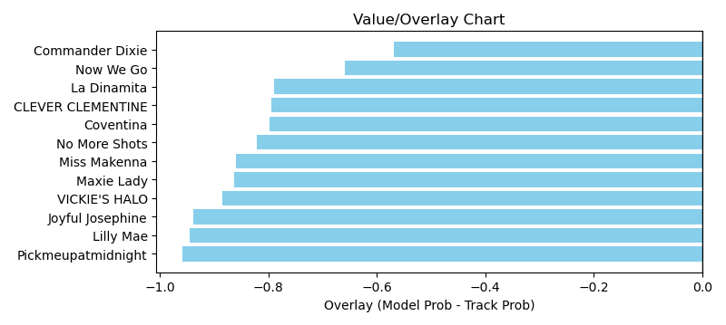

NOTE: GCSF - Global Combined Speed Figure

# Race: TOP | 2025-03-30 | Race #2 | Post: 13:07 | Track: OAKLAWN PARK

Track: OAKLAWN PARK

|  |  |  |  |  |  |
| --- | --- | --- | --- | --- | --- |
| Program # | Horse Name | Morn Odds | GCSF | Model Score | Win Prob (%) |
| 1 | Atta Party | 15-1 | 97.7 | 1.03 | 7.03 |
| 2 | Changing Times | 10-1 | 89.5 | 1.14 | 10.83 |
| 3 | Allo Enry | 4-1 | 88.5 | 1.05 | 7.62 |
| 4 | Macho Ronnie | 12-1 | 99.9 | 0.93 | 4.48 |
| 5 | Cooler King | 30-1 | 94.4 | 0.75 | 1.78 |
| 6 | I'm an Oak | 10-1 | 100.0 | 0.77 | 1.96 |
| 7 | Choctaw Zip | 5-2 | 102.5 | 1.50 | 35.55 |
| 8 | Reef's Destiny | 20-1 | 103.5 | 0.83 | 2.76 |
| 9 | Rocket Sanders | 8-1 | 100.1 | 1.07 | 8.19 |
| 10 | You Vee Cee | 6-1 | 101.0 | 0.99 | 5.88 |
| 11 | Holding Pattern | 5-1 | 99.9 | 1.21 | 13.91 |

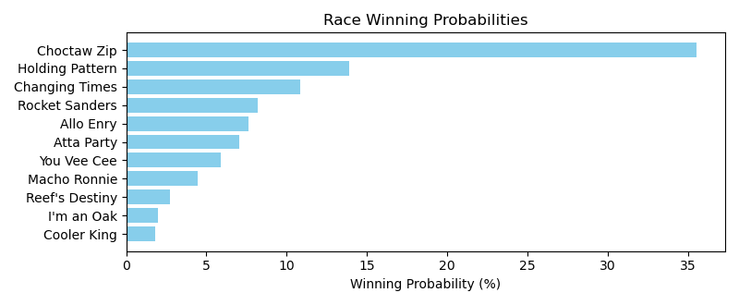

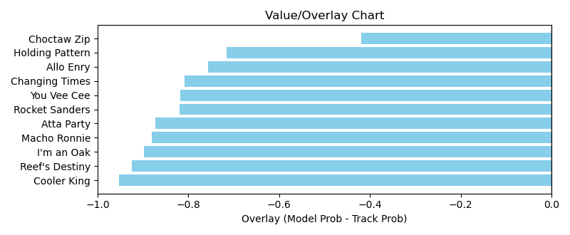

NOTE: GCSF - Global Combined Speed Figure

# Race: TOP | 2025-03-30 | Race #3 | Post: 13:39 | Track: OAKLAWN PARK

Track: OAKLAWN PARK

|  |  |  |  |  |  |
| --- | --- | --- | --- | --- | --- |
| Program # | Horse Name | Morn Odds | GCSF | Model Score | Win Prob (%) |
| 1 | Fashion Rage | 3-1 | 114.5 | 1.31 | 19.28 |
| 2 | Donya Know It | 15-1 | 96.6 | 0.96 | 4.88 |
| 3 | Sequin Lady | 7-2 | 97.3 | 1.25 | 15.56 |
| 4 | Adiva | 5-2 | 100.1 | 1.24 | 15.01 |
| 5 | Royal Blush | 20-1 | 98.2 | 1.01 | 6.27 |
| 6 | Singing Emma | 12-1 | 84.5 | 0.96 | 5.06 |
| 7 | H. T. Xena | 15-1 | 97.2 | 0.88 | 3.36 |
| 8 | Divine Gal | 10-1 | 98.6 | 0.80 | 2.22 |
| 9 | Floating | 8-1 | 92.8 | 1.35 | 21.75 |
| 10 | Miesha | 20-1 | 102.4 | 0.79 | 2.05 |
| 11 | Scrupulous | 15-1 | 99.1 | 0.94 | 4.56 |

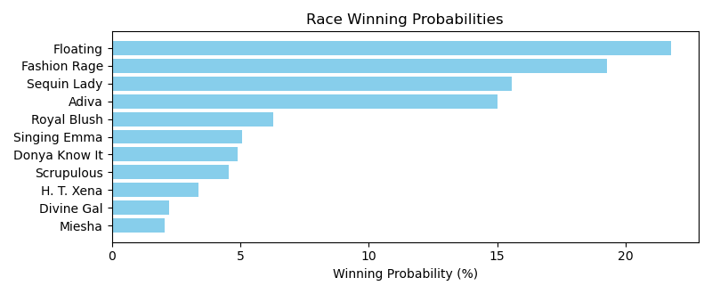

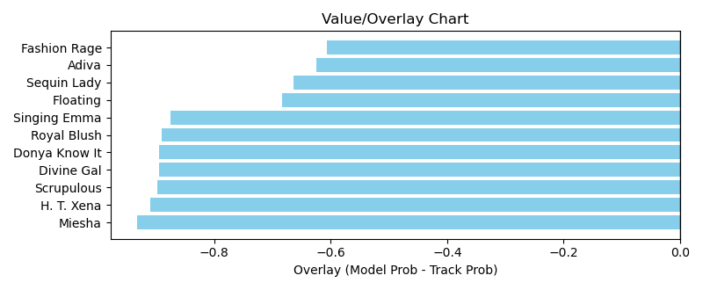

NOTE: GCSF - Global Combined Speed Figure

# Race: TOP | 2025-03-30 | Race #4 | Post: 14:10 | Track: OAKLAWN PARK

Track: OAKLAWN PARK

|  |  |  |  |  |  |
| --- | --- | --- | --- | --- | --- |
| Program # | Horse Name | Morn Odds | GCSF | Model Score | Win Prob (%) |
| 1 | On a Spree | 3-1 | 86.6 | 1.25 | 15.13 |
| 2 | Shot of Courage | 15-1 | 97.3 | 1.12 | 9.41 |
| 3 | Drifter | 15-1 | 122.2 | 1.02 | 6.18 |
| 4 | Seven Flat | 5-1 | 114.5 | 1.14 | 10.31 |
| 5 | Tiwanaku | 7-2 | 86.1 | 1.48 | 31.44 |
| 6 | Home Run Trick | 15-1 | 94.9 | 1.01 | 6.06 |
| 7 | Tie Breaker | 30-1 | 113.0 | 0.74 | 1.50 |
| 8 | Khozy My Boy | 30-1 | 91.9 | 0.75 | 1.67 |
| 9 | Vivir Con Alegria (CHI) | 2-1 | 99.2 | 1.06 | 7.41 |
| 10 | Chaos Reigns | 20-1 | 91.6 | 1.06 | 7.45 |
| 11 | Lions Not Sheep | 15-1 | 94.1 | 0.89 | 3.42 |

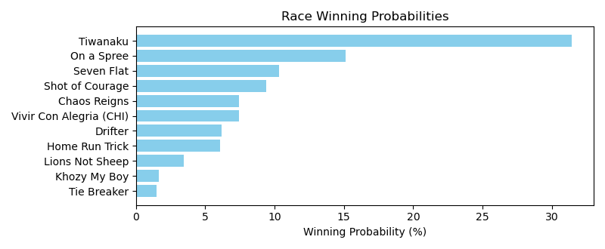

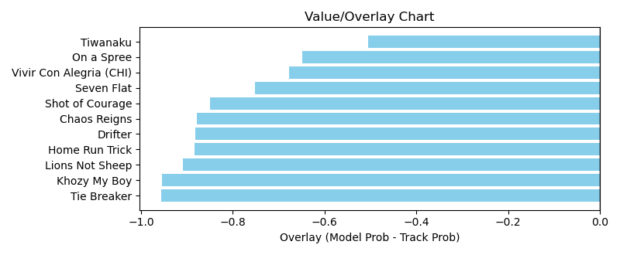

NOTE: GCSF - Global Combined Speed Figure

# Race: TOP | 2025-03-30 | Race #5 | Post: 14:42 | Track: OAKLAWN PARK

Track: OAKLAWN PARK

|  |  |  |  |  |  |
| --- | --- | --- | --- | --- | --- |
| Program # | Horse Name | Morn Odds | GCSF | Model Score | Win Prob (%) |
| 1 | Boltoro | 3-1 | 104.2 | 1.52 | 36.56 |
| 1A | Super Enticing | 3-1 | 96.6 | 0.98 | 5.44 |
| 2 | Royal Laughter | 6-1 | 108.1 | 0.95 | 4.82 |
| 3 | Undecoded | 30-1 | 95.4 | 0.76 | 1.83 |
| 4 | Big Bad Diva | 9-2 | 92.9 | 1.05 | 7.23 |
| 5 | Saranac Lake | 10-1 | 98.5 | 0.93 | 4.22 |
| 6 | Templar Red | 7-2 | 98.5 | 1.20 | 12.95 |
| 7 | Chai Tea | 30-1 | 124.7 | 0.75 | 1.73 |
| 8 | Lady Mercedes | 4-1 | 99.1 | 1.02 | 6.34 |
| 9 | Clearly Creeps | 12-1 | 96.7 | 0.89 | 3.63 |
| 10 | Butterfly Queen | 20-1 | 96.2 | 0.81 | 2.31 |
| 11 | It'sfiftyshadetime | 8-1 | 106.0 | 1.03 | 6.84 |
| 12 | Fearless Kristie | 20-1 | 115.7 | 0.97 | 5.09 |
| 13 | Right Trappe | 30-1 | 95.5 | 0.67 | 1.01 |

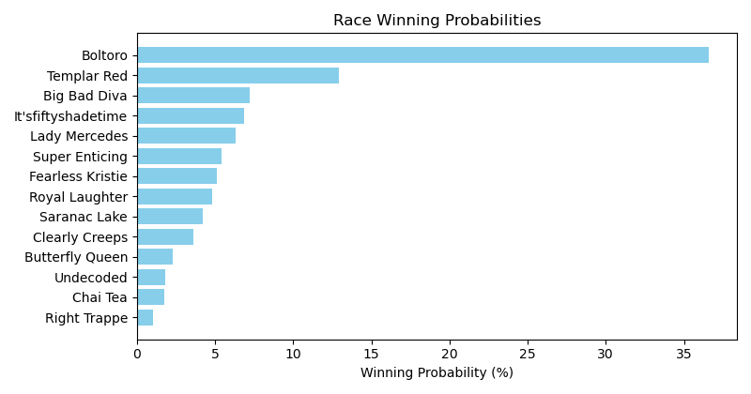

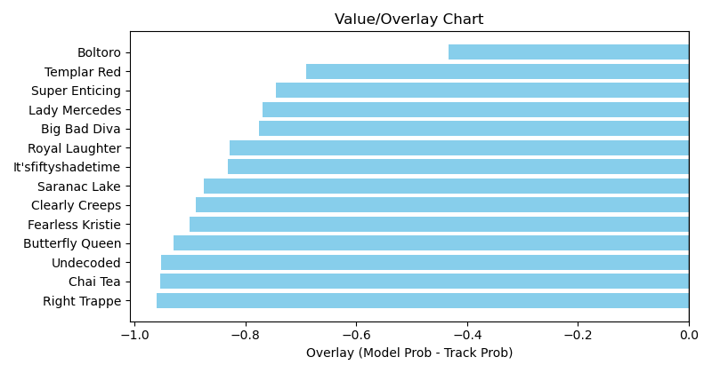

NOTE: GCSF - Global Combined Speed Figure

# Race: TOP | 2025-03-30 | Race #6 | Post: 15:13 | Track: OAKLAWN PARK

Track: OAKLAWN PARK

|  |  |  |  |  |  |
| --- | --- | --- | --- | --- | --- |
| Program # | Horse Name | Morn Odds | GCSF | Model Score | Win Prob (%) |
| 1 | Dinner At Crumpies | 15-1 | 114.7 | 1.00 | 4.27 |
| 2 | Ready Shoes | 10-1 | 94.6 | 0.89 | 2.52 |
| 3 | Afleet Sky | 20-1 | 89.9 | 0.93 | 3.08 |
| 4 | Burlsworth | 5-2 | 109.8 | 1.70 | 43.01 |
| 5 | Bellamys Roan | 30-1 | 112.8 | 0.72 | 0.99 |
| 6 | Hoppin John | 3-1 | 88.3 | 1.36 | 16.55 |
| 7 | Miri a Coincidence | 10-1 | 124.6 | 0.85 | 2.13 |
| 8 | King Peanut | 15-1 | 111.9 | 1.06 | 5.54 |
| 9 | Mansoura | 30-1 | 93.2 | 0.68 | 0.80 |
| 10 | Cybertown | 7-2 | 91.4 | 1.17 | 8.53 |
| 11 | Reveille Valley | 15-1 | 99.5 | 1.06 | 5.61 |
| 12 | Devils Fork | 15-1 | 89.9 | 0.97 | 3.70 |
| 13 | dq-Where's Randy | 12-1 | 109.1 | 0.94 | 3.28 |

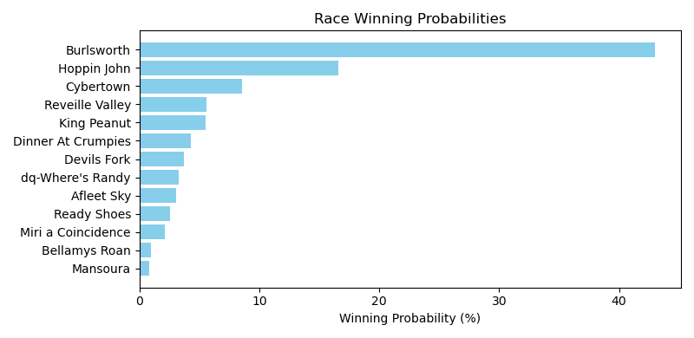

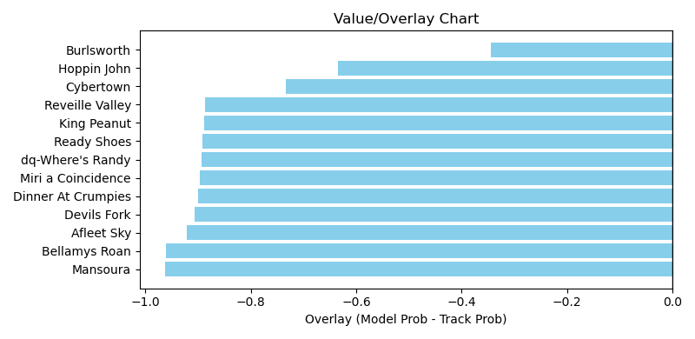

NOTE: GCSF - Global Combined Speed Figure

# Race: TOP | 2025-03-30 | Race #7 | Post: 15:45 | Track: OAKLAWN PARK

Track: OAKLAWN PARK

|  |  |  |  |  |  |
| --- | --- | --- | --- | --- | --- |
| Program # | Horse Name | Morn Odds | GCSF | Model Score | Win Prob (%) |
| 1 | Landing Craft | 5-1 | 86.5 | 1.07 | 9.54 |
| 2 | Max Got Excited | 8-1 | 111.5 | 1.07 | 9.34 |
| 3 | Gryphon | 20-1 | 93.4 | 0.80 | 2.57 |
| 4 | Hola Joey | 12-1 | 110.5 | 1.35 | 25.67 |
| 5 | Clever Again | 2-1 | 100.0 | 1.33 | 24.09 |
| 6 | Bout Tree Fiddy | 30-1 | 89.4 | 0.70 | 1.43 |
| 7 | Gaming | 9-5 | 91.7 | 1.27 | 19.80 |
| 8 | Perfect Force | 9-2 | 90.0 | 1.02 | 7.55 |

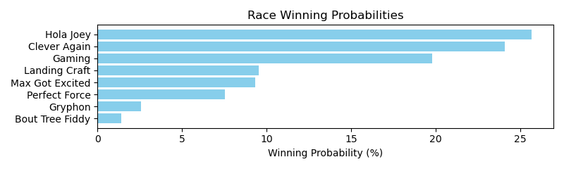

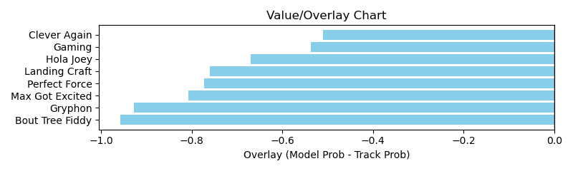

NOTE: GCSF - Global Combined Speed Figure

# Race: TOP | 2025-03-30 | Race #8 | Post: 16:16 | Track: OAKLAWN PARK

Track: OAKLAWN PARK

|  |  |  |  |  |  |
| --- | --- | --- | --- | --- | --- |
| Program # | Horse Name | Morn Odds | GCSF | Model Score | Win Prob (%) |
| 1 | SUPERMODEL | 30-1 | 100.0 | 1.04 | 5.71 |
| 2 | SOME SWEET GAL | 3-1 | 100.0 | 1.24 | 12.38 |
| 3 | Lady of Silence | 7-2 | 100.0 | 1.49 | 27.10 |
| 4 | Miss Elle | 30-1 | 106.6 | 0.68 | 0.90 |
| 5 | TRUE PASSION | 12-1 | 100.0 | 1.00 | 4.77 |
| 6 | LADY OF LIGHT | 20-1 | 100.0 | 1.05 | 5.93 |
| 7 | Braken Good | 6-1 | 100.0 | 1.23 | 11.75 |
| 8 | Super Costly | 30-1 | 100.0 | 1.02 | 5.32 |
| 9 | Yes Ma'am | 20-1 | 93.4 | 0.69 | 0.98 |
| 10 | Fall Colors | 20-1 | 100.0 | 0.97 | 4.30 |
| 11 | Ride the Broom | 15-1 | 100.0 | 1.00 | 4.76 |
| 12 | Mendela | 2-1 | 100.0 | 1.32 | 16.10 |

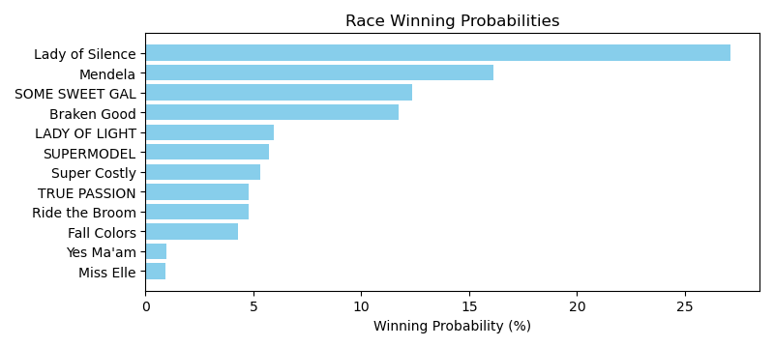

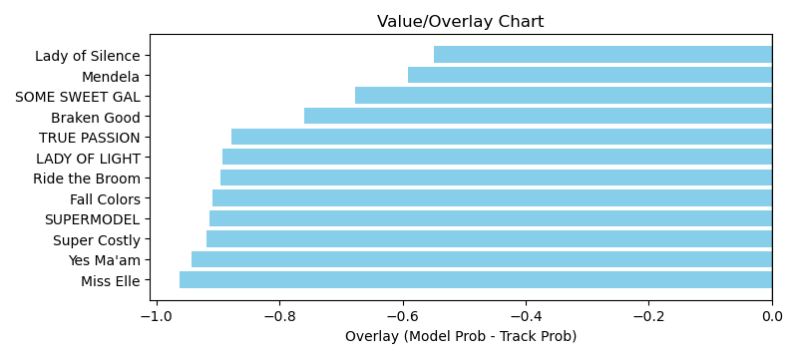

NOTE: GCSF - Global Combined Speed Figure

# Race: TOP | 2025-03-30 | Race #9 | Post: 16:48 | Track: OAKLAWN PARK

Track: OAKLAWN PARK

|  |  |  |  |  |  |
| --- | --- | --- | --- | --- | --- |
| Program # | Horse Name | Morn Odds | GCSF | Model Score | Win Prob (%) |
| 1 | Good Call | 15-1 | 93.4 | 1.17 | 4.73 |
| 2 | Trouble in Love | 5-2 | 100.0 | 1.52 | 14.55 |
| 3 | Whata Moon | 12-1 | 100.0 | 1.17 | 4.68 |
| 4 | Praying | 9-2 | 99.5 | 1.28 | 6.99 |
| 5 | Eskenforaraise | 20-1 | 97.7 | 1.05 | 2.88 |
| 6 | Viggiedal | 4-1 | 107.0 | 0.99 | 2.23 |
| 7 | Miss Martini | 2-1 | 93.4 | 2.11 | 61.66 |
| 8 | Complex Secret | 30-1 | 95.2 | 0.80 | 0.91 |
| 9 | Spankerboom | 30-1 | 91.0 | 0.70 | 0.51 |
| 10 | Wisconsin Gal | 30-1 | 86.2 | 0.79 | 0.86 |

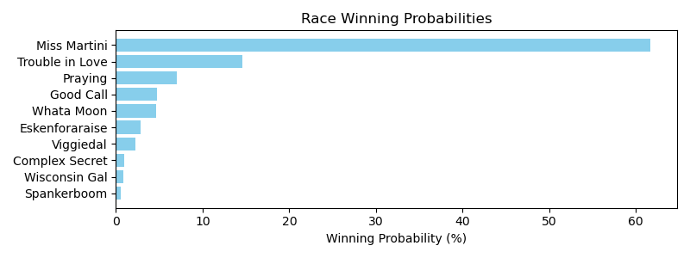

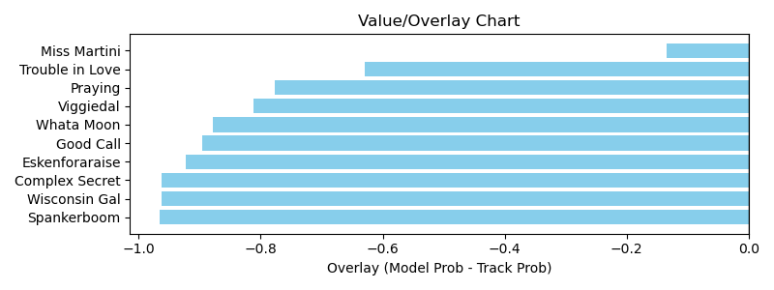

NOTE: GCSF - Global Combined Speed Figure

# Race: TOP | 2025-03-30 | Race #10 | Post: 17:20 | Track: OAKLAWN PARK

Track: OAKLAWN PARK

|  |  |  |  |  |  |
| --- | --- | --- | --- | --- | --- |
| Program # | Horse Name | Morn Odds | GCSF | Model Score | Win Prob (%) |
| 1 | Songmaker | 7-2 | 93.4 | 1.34 | 19.75 |
| 2 | Mia's Mom | 30-1 | 106.6 | 0.55 | 0.40 |
| 3 | Gun Twirl | 12-1 | 106.6 | 0.60 | 0.59 |
| 4 | Vino Tiempo | 15-1 | 96.3 | 0.97 | 4.69 |
| 5 | Calamity | 2-1 | 93.3 | 1.42 | 24.94 |
| 6 | Rush to Glory | 15-1 | 89.9 | 0.89 | 3.20 |
| 7 | Seeking a Prayer | 10-1 | 100.0 | 1.24 | 13.64 |
| 8 | Seraphia | 12-1 | 93.4 | 1.01 | 5.61 |
| 9 | Buriana | 15-1 | 109.5 | 0.76 | 1.67 |
| 10 | SAINT NANCY S | 12-1 | 100.0 | 1.01 | 5.64 |
| 11 | Win for Speight | 5-1 | 100.0 | 1.13 | 9.13 |
| 12 | Meg's Foxy Grey | 12-1 | 100.0 | 1.17 | 10.74 |

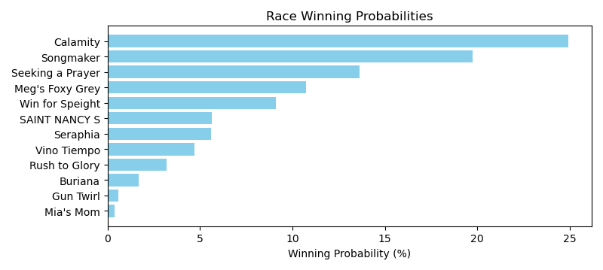

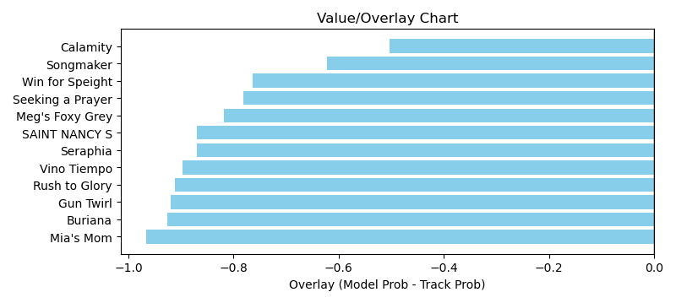

NOTE: GCSF - Global Combined Speed Figure

# Race: HOU | 2025-03-30 | Race #1 | Post: 13:00 | Track: SAM HOUSTON RACE PARK

Track: SAM HOUSTON RACE PARK

|  |  |  |  |  |  |
| --- | --- | --- | --- | --- | --- |
| Program # | Horse Name | Morn Odds | GCSF | Model Score | Win Prob (%) |
| 1 | No Moro Here | 4-1 | 106.6 | 0.49 | 1.51 |
| 2 | Angel in the Air | 3-1 | 96.6 | 0.68 | 6.22 |
| 3 | Chip Alternative | 6-1 | 100.0 | 1.15 | 61.22 |
| 4 | Come On Sing | 20-1 | 106.6 | 0.77 | 10.56 |
| 5 | Fun as All Git Out | 1-1 | 93.4 | 0.63 | 4.33 |
| 6 | Along Came Thunder | 8-1 | 116.2 | 0.85 | 16.17 |

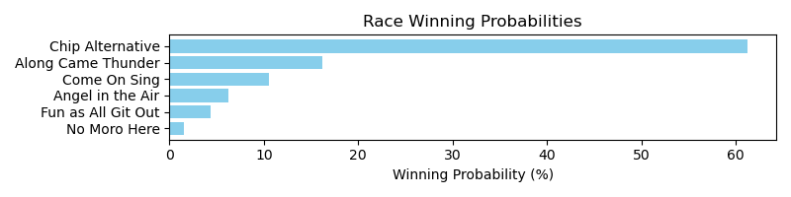

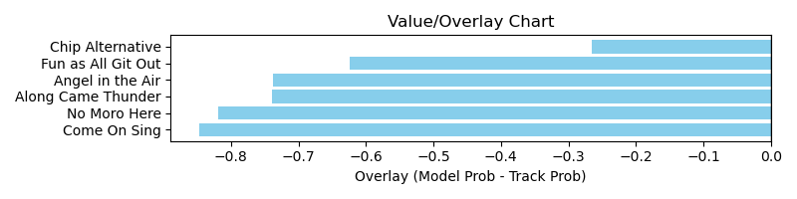

NOTE: GCSF - Global Combined Speed Figure

# Race: HOU | 2025-03-30 | Race #2 | Post: 13:30 | Track: SAM HOUSTON RACE PARK

Track: SAM HOUSTON RACE PARK

|  |  |  |  |  |  |
| --- | --- | --- | --- | --- | --- |
| Program # | Horse Name | Morn Odds | GCSF | Model Score | Win Prob (%) |
| 1 | Very Unlikely | 5-2 | 96.1 | 0.64 | 2.92 |
| 2 | Tiz a Knockout | 7-2 | 95.5 | 1.08 | 29.46 |
| 3 | Real Mischievous | 12-1 | 106.6 | 1.00 | 21.01 |
| 4 | Hurryandgetready | 15-1 | 100.0 | 0.81 | 8.32 |
| 5 | Freed by Magic | 20-1 | 119.0 | 0.56 | 1.65 |
| 6 | Ziah Y G | 12-1 | 93.4 | 0.56 | 1.63 |
| 7 | Maybe So | 9-5 | 96.3 | 1.08 | 28.61 |
| 8 | Zippy Season | 8-1 | 106.6 | 0.76 | 6.40 |

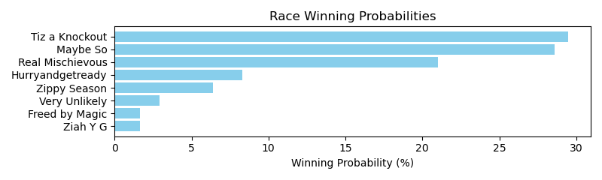

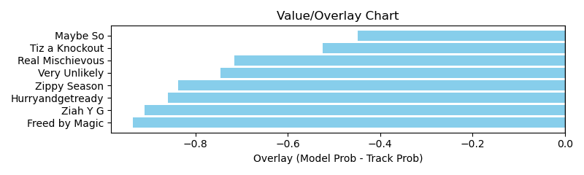

NOTE: GCSF - Global Combined Speed Figure

# Race: HOU | 2025-03-30 | Race #3 | Post: 14:00 | Track: SAM HOUSTON RACE PARK

Track: SAM HOUSTON RACE PARK

|  |  |  |  |  |  |
| --- | --- | --- | --- | --- | --- |
| Program # | Horse Name | Morn Odds | GCSF | Model Score | Win Prob (%) |
| 1 | Coffee Kisses | 8-1 | 100.0 | 1.30 | 24.37 |
| 2 | Moon Mist | 6-1 | 100.0 | 1.23 | 18.88 |
| 3 | Just a Coed | 6-5 | 100.3 | 1.21 | 17.94 |
| 4 | Circa Star | 12-1 | 107.6 | 0.95 | 6.29 |
| 5 | COMPENDIUM | 5-2 | 100.0 | 1.11 | 12.08 |
| 6 | Barbanera | 4-1 | 100.0 | 1.25 | 20.44 |

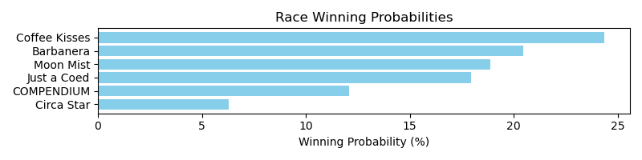

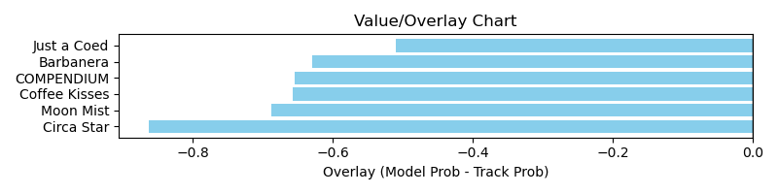

NOTE: GCSF - Global Combined Speed Figure

# Race: HOU | 2025-03-30 | Race #4 | Post: 14:30 | Track: SAM HOUSTON RACE PARK

Track: SAM HOUSTON RACE PARK

|  |  |  |  |  |  |
| --- | --- | --- | --- | --- | --- |
| Program # | Horse Name | Morn Odds | GCSF | Model Score | Win Prob (%) |
| 1 | Ooh La Da Stoops | 2-1 | 101.4 | 1.11 | 8.09 |
| 2 | God Knows Why | 10-1 | 94.2 | 1.05 | 6.29 |
| 3 | Indy La Primera | 6-1 | 96.0 | 1.49 | 29.54 |
| 4 | Yoda Winner | 12-1 | 100.0 | 1.11 | 8.20 |
| 5 | Bling It to Me | 5-2 | 108.3 | 1.57 | 36.20 |
| 6 | Cranky Sheila | 8-1 | 94.1 | 0.86 | 2.65 |
| 7 | Avaling | 7-2 | 92.6 | 1.14 | 9.03 |

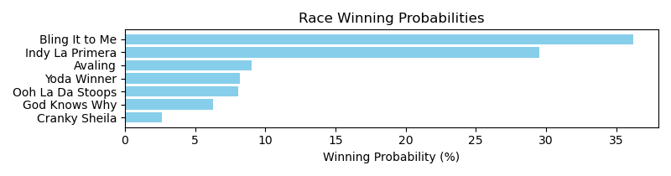

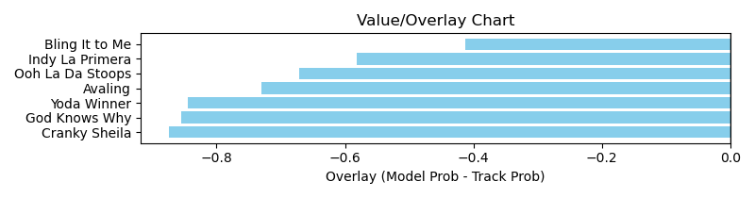

NOTE: GCSF - Global Combined Speed Figure

# Race: HOU | 2025-03-30 | Race #5 | Post: 15:00 | Track: SAM HOUSTON RACE PARK

Track: SAM HOUSTON RACE PARK

|  |  |  |  |  |  |
| --- | --- | --- | --- | --- | --- |
| Program # | Horse Name | Morn Odds | GCSF | Model Score | Win Prob (%) |
| 1 | Just Hangin Ridge | 30-1 | 98.9 | 0.61 | 0.50 |
| 2 | Silver Assassin | 3-1 | 90.9 | 1.36 | 16.41 |
| 3 | Ghurair's Warrior | 20-1 | 97.0 | 0.73 | 1.07 |
| 4 | Baby of the Family | 15-1 | 96.1 | 0.70 | 0.88 |
| 5 | The Devil's Bet | 5-2 | 105.9 | 1.76 | 50.92 |
| 6 | Texas Creed | 9-2 | 102.3 | 1.17 | 8.57 |
| 7 | Crazy Ridge | 20-1 | 95.5 | 0.80 | 1.61 |
| 8 | Daryls Trump Card | 6-1 | 101.3 | 1.31 | 14.05 |
| 9 | Flying Caesar | 12-1 | 101.2 | 0.92 | 3.00 |
| 10 | Sparra | 8-1 | 95.1 | 0.92 | 2.98 |

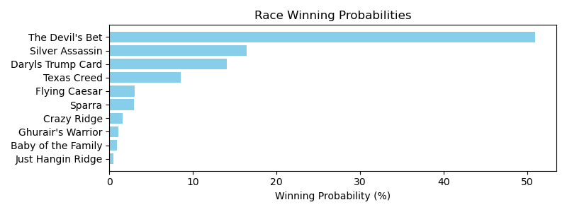

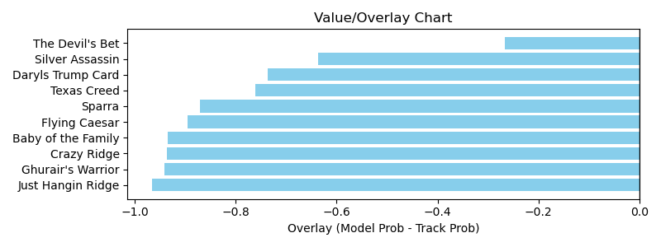

NOTE: GCSF - Global Combined Speed Figure

# Race: HOU | 2025-03-30 | Race #6 | Post: 15:35 | Track: SAM HOUSTON RACE PARK

Track: SAM HOUSTON RACE PARK

|  |  |  |  |  |  |
| --- | --- | --- | --- | --- | --- |
| Program # | Horse Name | Morn Odds | GCSF | Model Score | Win Prob (%) |
| 1 | Levy | 20-1 | 106.9 | 0.95 | 2.24 |
| 2 | United Patriot | 8-1 | 115.8 | 1.21 | 6.30 |
| 3 | Deanos Cape | 6-1 | 97.4 | 1.06 | 3.57 |
| 4 | Playboy Style | 30-1 | 91.0 | 0.90 | 1.78 |
| 5 | Special Moment | 8-1 | 96.7 | 1.18 | 5.61 |
| 6 | Cool Memory | 20-1 | 92.2 | 0.76 | 0.81 |
| 7 | Shamayim | 4-1 | 97.6 | 1.89 | 44.19 |
| 8 | Hamazing Wisdom | 12-1 | 98.3 | 0.91 | 1.81 |
| 9 | Catholic Guilt | 5-2 | 95.9 | 1.69 | 27.46 |
| 10 | Legendary Lore | 7-2 | 117.9 | 1.20 | 6.23 |

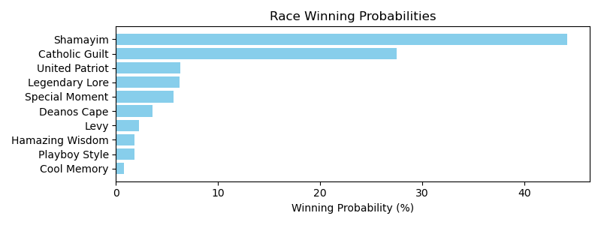

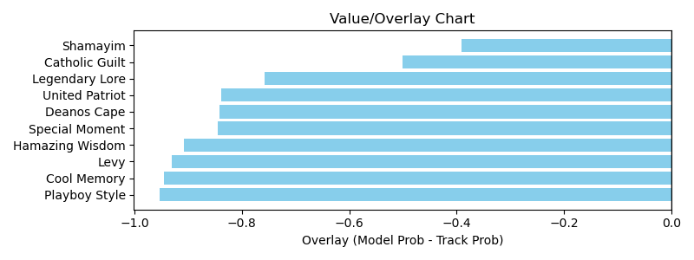

NOTE: GCSF - Global Combined Speed Figure

# Race: HOU | 2025-03-30 | Race #7 | Post: 16:05 | Track: SAM HOUSTON RACE PARK

Track: SAM HOUSTON RACE PARK

|  |  |  |  |  |  |
| --- | --- | --- | --- | --- | --- |
| Program # | Horse Name | Morn Odds | GCSF | Model Score | Win Prob (%) |
| 1 | Turn North | 6-5 | 92.0 | 1.89 | 55.85 |
| 2 | Texas Holdem | 6-1 | 101.0 | 1.35 | 12.64 |
| 3 | Essay | 20-1 | 96.3 | 0.74 | 0.90 |
| 4 | Tigers 'n Bears | 10-1 | 92.7 | 0.98 | 3.20 |
| 5 | My Little Prince | 8-1 | 109.8 | 0.83 | 1.48 |
| 6 | Fort Hood | 9-2 | 107.9 | 1.08 | 4.79 |
| 7 | Tx Code | 7-2 | 93.4 | 1.52 | 21.13 |

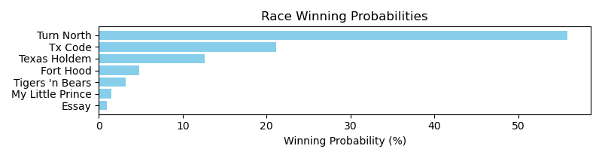

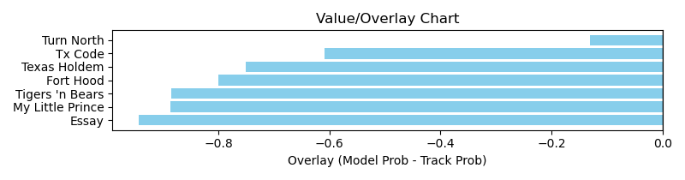

NOTE: GCSF - Global Combined Speed Figure

# Race: HOU | 2025-03-30 | Race #8 | Post: 16:35 | Track: SAM HOUSTON RACE PARK

Track: SAM HOUSTON RACE PARK

|  |  |  |  |  |  |
| --- | --- | --- | --- | --- | --- |
| Program # | Horse Name | Morn Odds | GCSF | Model Score | Win Prob (%) |
| 1 | KEEP THE KINGDOM | 8-1 | 100.0 | 1.10 | 10.27 |
| 2 | Dustins Denile | 6-1 | 106.6 | 1.40 | 29.35 |
| 3 | Valhalla Viking | 15-1 | 100.0 | 1.05 | 8.35 |
| 4 | Won More Time | 3-1 | 100.0 | 1.25 | 18.08 |
| 5 | Solevo | 2-1 | 97.1 | 0.86 | 3.49 |
| 6 | A LONG TIME | 12-1 | 100.0 | 1.21 | 15.34 |
| 7 | Roaring Rapids | 4-1 | 93.4 | 1.17 | 13.29 |
| 8 | Carry the Flag | 15-1 | 94.9 | 0.74 | 1.83 |

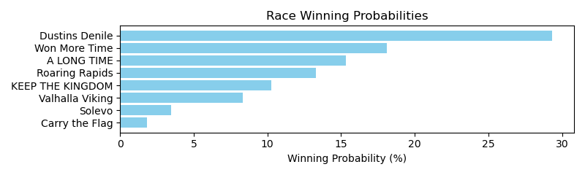

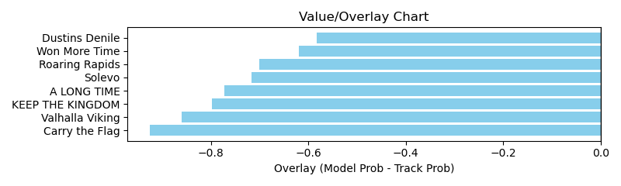

NOTE: GCSF - Global Combined Speed Figure

# Race: TSA | 2025-03-30 | Race #1 | Post: 13:00 | Track: SANTA ANITA PARK

Track: SANTA ANITA PARK

|  |  |  |  |  |  |
| --- | --- | --- | --- | --- | --- |
| Program # | Horse Name | Morn Odds | GCSF | Model Score | Win Prob (%) |
| 1 | Tenacious Candy | 20-1 | 100.0 | 1.07 | 9.55 |
| 2 | Siempre Naman | 4-1 | 100.0 | 1.26 | 19.76 |
| 3 | Saint Shelia | 15-1 | 93.4 | 0.56 | 0.55 |
| 4 | Walk Down Colgate | 8-1 | 100.0 | 1.07 | 9.59 |
| 5 | Nephele | 13-8 | 93.4 | 1.27 | 20.36 |
| 6 | REBELEXIS | 6-1 | 100.0 | 0.99 | 6.77 |
| 7 | Smiling Rapper | 6-1 | 106.6 | 1.24 | 18.22 |
| 8 | Roman Bronze | 5-1 | 100.0 | 1.19 | 15.20 |

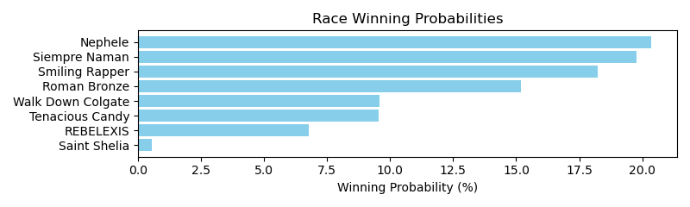

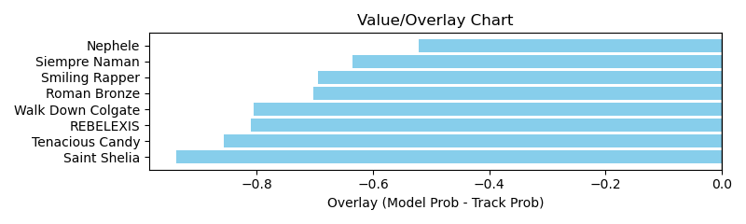

NOTE: GCSF - Global Combined Speed Figure

# Race: TSA | 2025-03-30 | Race #2 | Post: 13:29 | Track: SANTA ANITA PARK

Track: SANTA ANITA PARK

|  |  |  |  |  |  |
| --- | --- | --- | --- | --- | --- |
| Program # | Horse Name | Morn Odds | GCSF | Model Score | Win Prob (%) |
| 1 | Royal 'n Rando | 8-1 | 105.1 | 1.28 | 12.62 |
| 2 | Saqeel | 7-5 | 113.8 | 1.50 | 25.07 |
| 3 | Ready to Pounce | 9-5 | 98.0 | 1.76 | 49.39 |
| 4 | Joint Venture | 6-1 | 98.9 | 1.17 | 8.47 |
| 5 | Keep Movin' On | 7-2 | 96.9 | 1.01 | 4.45 |

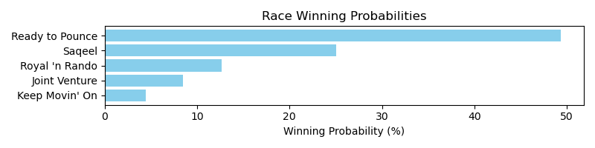

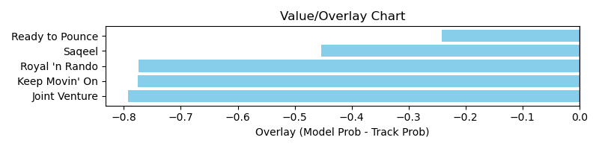

NOTE: GCSF - Global Combined Speed Figure

# Race: TSA | 2025-03-30 | Race #3 | Post: 14:00 | Track: SANTA ANITA PARK

Track: SANTA ANITA PARK

|  |  |  |  |  |  |
| --- | --- | --- | --- | --- | --- |
| Program # | Horse Name | Morn Odds | GCSF | Model Score | Win Prob (%) |
| 1 | Silver N Black | 6-5 | 106.2 | 1.28 | 26.99 |
| 2 | Elegant Life | 20-1 | 100.0 | 1.06 | 12.14 |
| 3 | White Mountain | 5-1 | 100.0 | 1.19 | 19.60 |
| 4 | The Gypsy Cowboy | 6-1 | 100.8 | 1.06 | 12.07 |
| 5 | Sinful King | 9-2 | 101.7 | 0.67 | 1.58 |
| 6 | Toppers Wager | 3-1 | 88.2 | 1.28 | 27.16 |
| 7 | Soul Music | 30-1 | 102.9 | 0.50 | 0.46 |

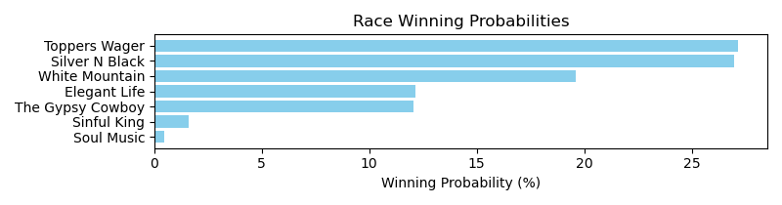

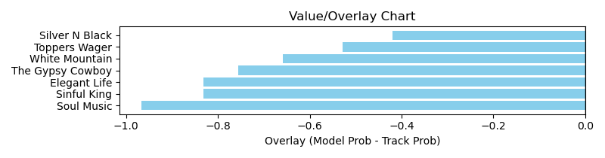

NOTE: GCSF - Global Combined Speed Figure

# Race: TSA | 2025-03-30 | Race #4 | Post: 14:30 | Track: SANTA ANITA PARK

Track: SANTA ANITA PARK

|  |  |  |  |  |  |
| --- | --- | --- | --- | --- | --- |
| Program # | Horse Name | Morn Odds | GCSF | Model Score | Win Prob (%) |
| 1 | Liberty Wolf | 15-1 | 100.9 | 0.95 | 13.07 |
| 2 | Littlebrotherjoey | 8-1 | 111.4 | 0.74 | 4.42 |
| 3 | Dazzle the Command | 5-2 | 90.0 | 1.09 | 22.93 |
| 4 | Monsieur | 10-1 | 95.2 | 0.89 | 9.42 |
| 5 | In Without Knockin | 7-2 | 96.7 | 0.83 | 7.16 |
| 6 | Updraft | 12-1 | 112.8 | 0.80 | 5.99 |
| 7 | Acero | 9-5 | 97.7 | 1.17 | 32.38 |
| 8 | Beau Brume | 20-1 | 93.4 | 0.75 | 4.63 |

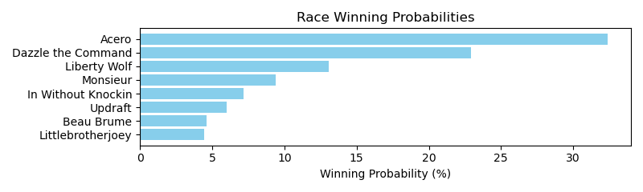

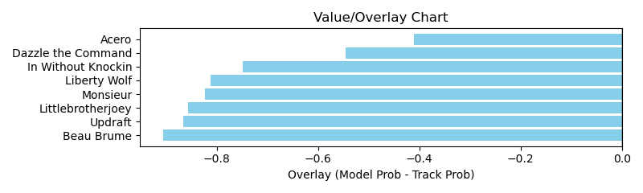

NOTE: GCSF - Global Combined Speed Figure

# Race: TSA | 2025-03-30 | Race #5 | Post: 15:00 | Track: SANTA ANITA PARK

Track: SANTA ANITA PARK

|  |  |  |  |  |  |
| --- | --- | --- | --- | --- | --- |
| Program # | Horse Name | Morn Odds | GCSF | Model Score | Win Prob (%) |
| 1 | Makenarita | 5-2 | 86.9 | 0.78 | 4.22 |
| 2 | Buds N Suds | 15-1 | 117.9 | 0.82 | 5.24 |
| 3 | Chokechery Shari | 20-1 | 106.6 | 0.52 | 0.75 |
| 4 | Maga Kai | 12-1 | 89.6 | 0.80 | 4.67 |
| 5 | Mrazek's Old Dream | 20-1 | 94.7 | 0.64 | 1.76 |
| 6 | Allihies | 15-1 | 100.0 | 1.12 | 20.11 |
| 7 | Aggro | 7-2 | 93.4 | 1.21 | 28.21 |
| 8 | Readytoriskitall | 6-5 | 100.0 | 1.27 | 35.04 |

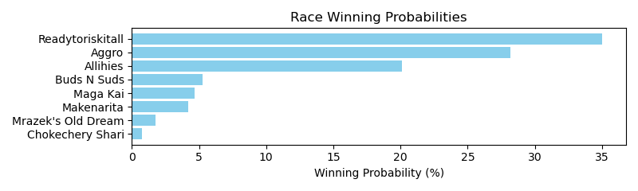

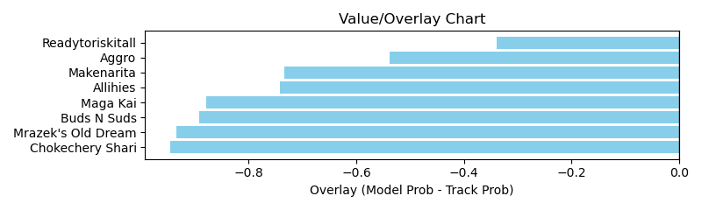

NOTE: GCSF - Global Combined Speed Figure

# Race: TSA | 2025-03-30 | Race #6 | Post: 15:30 | Track: SANTA ANITA PARK

Track: SANTA ANITA PARK

|  |  |  |  |  |  |
| --- | --- | --- | --- | --- | --- |
| Program # | Horse Name | Morn Odds | GCSF | Model Score | Win Prob (%) |
| 1 | DECAPO | 3-1 | 100.0 | 1.39 | 12.85 |
| 2 | War to Remember | 10-1 | 100.0 | 0.86 | 1.56 |
| 3 | Redial | 12-1 | 100.0 | 1.42 | 13.83 |
| 4 | Helicity | 8-1 | 101.8 | 1.09 | 4.39 |
| 5 | THIRTY TWO CHUNK | 6-1 | 100.0 | 1.24 | 7.77 |
| 6 | Charlie Foxtrot | 4-1 | 100.0 | 1.38 | 12.37 |
| 7 | King Stephen | 7-2 | 100.0 | 1.59 | 22.70 |
| 8 | Going Viral | 8-1 | 106.6 | 1.37 | 12.06 |
| 9 | CHIEF RENEGADE | 30-1 | 100.0 | 1.24 | 7.71 |
| 10 | Tex | 30-1 | 100.0 | 1.11 | 4.76 |

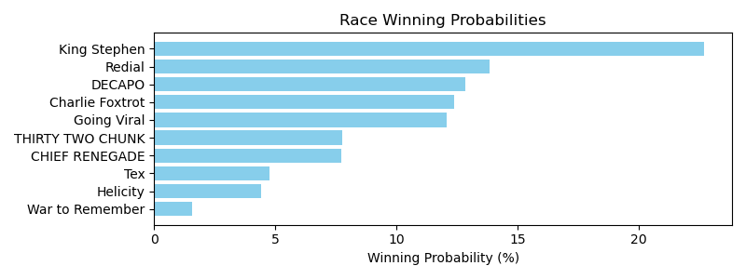

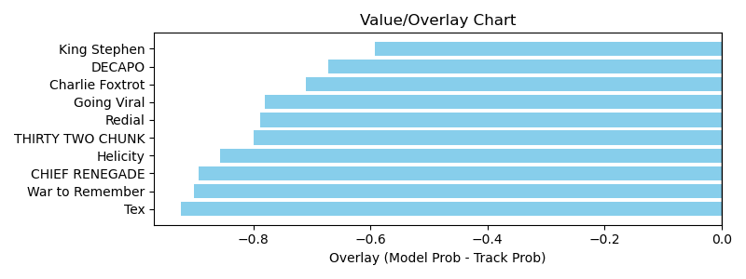

NOTE: GCSF - Global Combined Speed Figure

# Race: TSA | 2025-03-30 | Race #7 | Post: 16:00 | Track: SANTA ANITA PARK

Track: SANTA ANITA PARK

|  |  |  |  |  |  |
| --- | --- | --- | --- | --- | --- |
| Program # | Horse Name | Morn Odds | GCSF | Model Score | Win Prob (%) |
| 1 | Cody Boy | 5-1 | 103.4 | 1.04 | 8.78 |
| 2 | Pratchett | 13-8 | 106.7 | 1.59 | 55.69 |
| 3 | P Twentytwo | 6-1 | 100.0 | 1.22 | 17.10 |
| 4 | Uplift | 30-1 | 95.2 | 0.73 | 1.85 |
| 5 | Mendelssohns Music | 15-1 | 93.5 | 0.93 | 5.33 |
| 6 | Big Splash | 20-1 | 101.6 | 0.75 | 2.11 |
| 7 | Spiritist | 6-1 | 91.8 | 0.99 | 6.93 |
| 8 | Buckortwo | 5-2 | 99.6 | 0.76 | 2.20 |

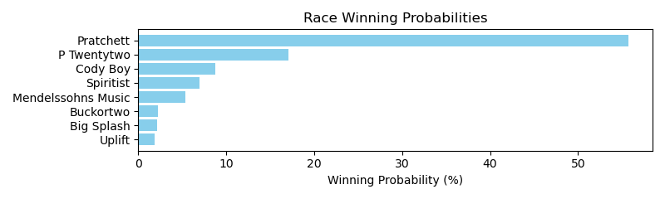

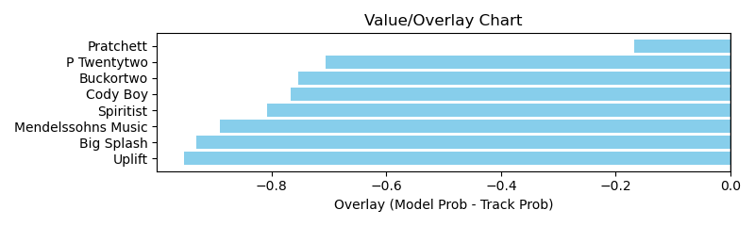

NOTE: GCSF - Global Combined Speed Figure

# Race: TSA | 2025-03-30 | Race #8 | Post: 16:30 | Track: SANTA ANITA PARK

Track: SANTA ANITA PARK

|  |  |  |  |  |  |
| --- | --- | --- | --- | --- | --- |
| Program # | Horse Name | Morn Odds | GCSF | Model Score | Win Prob (%) |
| 1 | Kings River Knight | 2-1 | 92.6 | 1.85 | 37.31 |
| 2 | Lovesick Blues | 15-1 | 111.8 | 1.13 | 4.32 |
| 3 | Clovisconnection | 10-1 | 103.4 | 1.04 | 3.05 |
| 4 | Book Smart | 20-1 | 103.7 | 1.10 | 3.86 |
| 5 | Tom Horn | 9-2 | 100.6 | 1.64 | 22.10 |
| 6 | Fast Buck | 4-1 | 91.7 | 1.25 | 6.79 |
| 7 | On the Whim | 5-1 | 89.7 | 1.29 | 7.75 |
| 8 | Lonesome Stew | 9-2 | 99.4 | 1.50 | 14.81 |

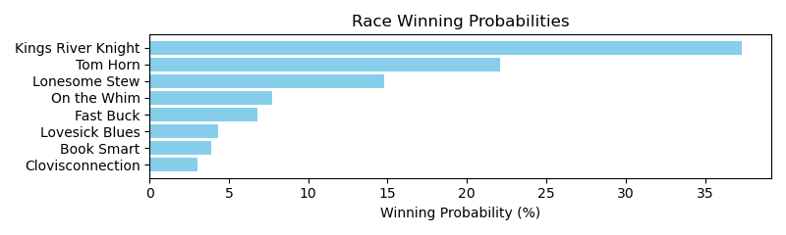

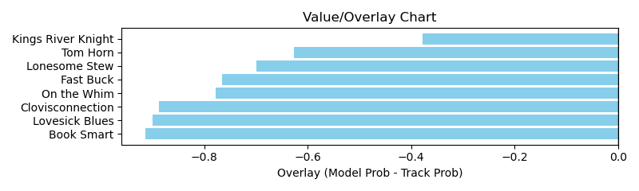

NOTE: GCSF - Global Combined Speed Figure

# Race: TSA | 2025-03-30 | Race #9 | Post: 17:00 | Track: SANTA ANITA PARK

Track: SANTA ANITA PARK

|  |  |  |  |  |  |
| --- | --- | --- | --- | --- | --- |
| Program # | Horse Name | Morn Odds | GCSF | Model Score | Win Prob (%) |
| 1 | Coulthard (IRE) | 12-1 | 96.9 | 0.88 | 3.09 |
| 2 | Divine Rascal | 15-1 | 98.2 | 0.89 | 3.26 |
| 3 | Touch of Zen | 30-1 | 101.8 | 0.92 | 3.76 |
| 4 | Big Don's Smiling | 6-1 | 95.3 | 0.92 | 3.81 |
| 5 | Quality Cat | 15-1 | 93.0 | 0.98 | 4.90 |
| 6 | Major Tom | 5-2 | 98.4 | 1.69 | 54.38 |
| 7 | Hermelinda's Fancy | 20-1 | 93.2 | 0.94 | 4.12 |
| 8 | Roy Hobbs | 9-2 | 106.7 | 0.96 | 4.46 |
| 9 | Runnin Ute | 5-1 | 104.2 | 0.88 | 3.03 |
| 10 | Love Candy | 20-1 | 97.3 | 0.98 | 5.02 |
| 11 | Momo's Kiddo | 12-1 | 97.5 | 1.05 | 6.85 |
| 12 | Warrens World | 10-1 | 88.1 | 0.89 | 3.34 |

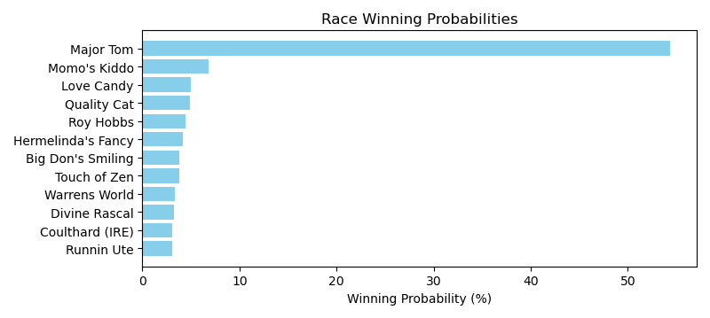

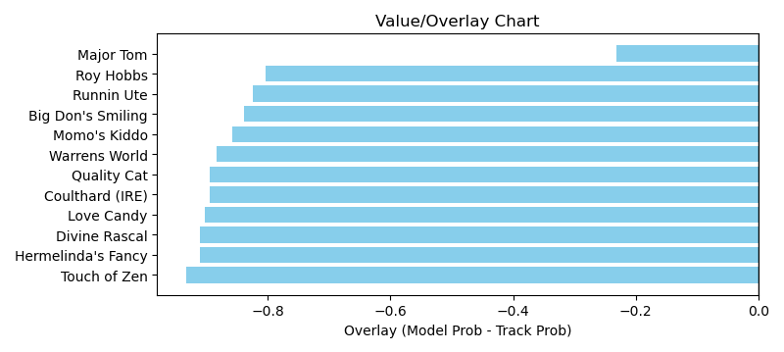

NOTE: GCSF - Global Combined Speed Figure

# Race: TSA | 2025-03-30 | Race #10 | Post: 17:30 | Track: SANTA ANITA PARK

Track: SANTA ANITA PARK

|  |  |  |  |  |  |
| --- | --- | --- | --- | --- | --- |
| Program # | Horse Name | Morn Odds | GCSF | Model Score | Win Prob (%) |
| 1 | Kentucky Gal (IRE) | 5-1 | 100.0 | 1.35 | 10.42 |
| 2 | Tiaraqueen (GB) | 15-1 | 107.2 | 0.74 | 0.74 |
| 3 | Starts Now | 10-1 | 117.8 | 1.06 | 3.58 |
| 4 | Big Mama Sue | 30-1 | 106.7 | 0.95 | 2.22 |
| 5 | Mizzyaan | 8-1 | 107.5 | 1.17 | 5.65 |
| 6 | Strutting (GB) | 7-2 | 93.4 | 1.41 | 12.53 |
| 7 | Public Assembly | 5-1 | 93.4 | 1.63 | 23.88 |
| 8 | ESMERAY (IRE) | 10-1 | 100.0 | 1.16 | 5.40 |
| 9 | Cheekiest | 30-1 | 104.4 | 1.40 | 12.28 |
| 10 | Paradise Lake | 5-2 | 95.9 | 1.55 | 18.95 |
| 11 | dh-Ima Joker | 20-1 | 107.9 | 1.11 | 4.37 |

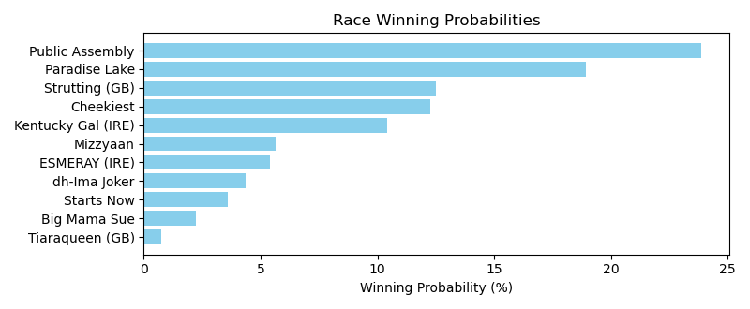

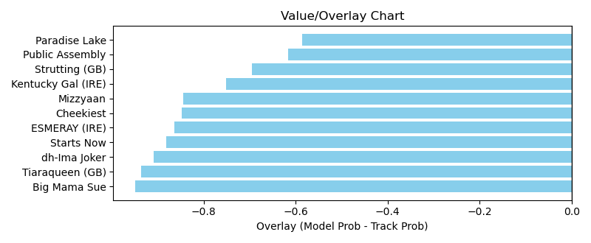

NOTE: GCSF - Global Combined Speed Figure

# Race: TAM | 2025-03-30 | Race #1 | Post: 12:00 | Track: TAMPA BAY DOWNS

Track: TAMPA BAY DOWNS

|  |  |  |  |  |  |
| --- | --- | --- | --- | --- | --- |
| Program # | Horse Name | Morn Odds | GCSF | Model Score | Win Prob (%) |
| 1 | Goonie | 12-1 | 97.4 | 0.86 | 4.14 |
| 2 | Spun to Purfection | 6-1 | 100.0 | 1.10 | 12.35 |
| 3 | Weather Lady | 30-1 | 106.9 | 0.47 | 0.30 |
| 4 | Michaela | 5-2 | 96.3 | 0.98 | 7.26 |
| 5 | Crossati | 15-1 | 103.5 | 0.53 | 0.52 |
| 6 | Qurbaan D Oro | 30-1 | 95.5 | 0.81 | 3.16 |
| 7 | Alice Fantastic | 20-1 | 100.0 | 1.15 | 15.17 |
| 8 | Thunder Princess | 5-1 | 111.0 | 0.91 | 5.48 |
| 9 | Backseat Romance | 3-1 | 91.0 | 1.33 | 27.65 |
| 10 | Sunny Monday | 30-1 | 100.0 | 0.99 | 7.68 |
| 11 | Anna Jean | 12-1 | 99.2 | 0.84 | 3.75 |
| 12 | When in Roma | 5-1 | 92.9 | 1.06 | 10.22 |
| 13 | Dorotea Dream | 7-2 | 99.3 | 0.68 | 1.51 |
| 14 | Willful Rose | 30-1 | 95.2 | 0.59 | 0.82 |

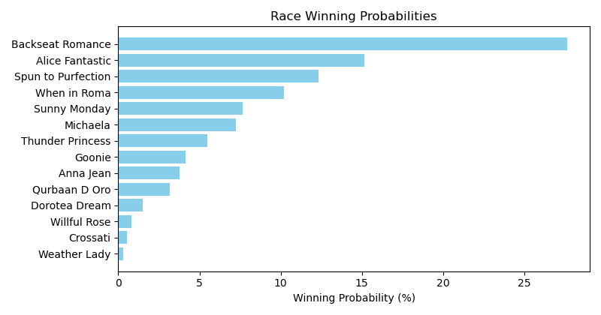

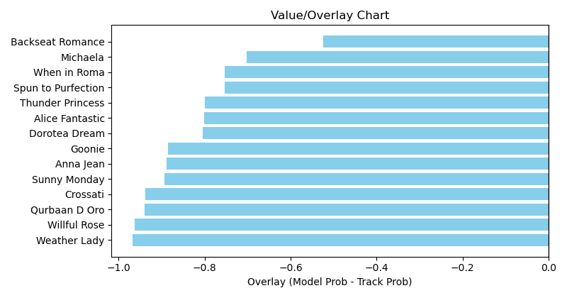

NOTE: GCSF - Global Combined Speed Figure

# Race: TAM | 2025-03-30 | Race #2 | Post: 12:30 | Track: TAMPA BAY DOWNS

Track: TAMPA BAY DOWNS

|  |  |  |  |  |  |
| --- | --- | --- | --- | --- | --- |
| Program # | Horse Name | Morn Odds | GCSF | Model Score | Win Prob (%) |
| 1 | Breath Deeply | 12-1 | 102.2 | 1.21 | 6.03 |
| 2 | Braggadocious | 7-2 | 104.9 | 1.63 | 22.51 |
| 3 | Gun Right | 6-1 | 113.5 | 1.18 | 5.45 |
| 4 | Estilo Magico | 4-1 | 95.2 | 1.18 | 5.53 |
| 5 | Bandero | 30-1 | 94.3 | 0.88 | 1.50 |
| 6 | Diamond Messa | 6-1 | 113.0 | 1.55 | 18.14 |
| 7 | Admiral's Wave | 3-1 | 96.4 | 1.58 | 19.41 |
| 8 | Bounteous | 4-1 | 97.8 | 1.14 | 4.60 |
| 9 | Street Vendor | 30-1 | 97.5 | 0.80 | 1.02 |
| 10 | Poseidons Myth | 30-1 | 102.9 | 1.34 | 9.47 |
| 11 | Haberdashery | 8-1 | 95.3 | 0.81 | 1.06 |
| 12 | Leopardi | 20-1 | 95.8 | 0.81 | 1.04 |
| 13 | Quencio | 6-1 | 111.7 | 1.11 | 4.24 |

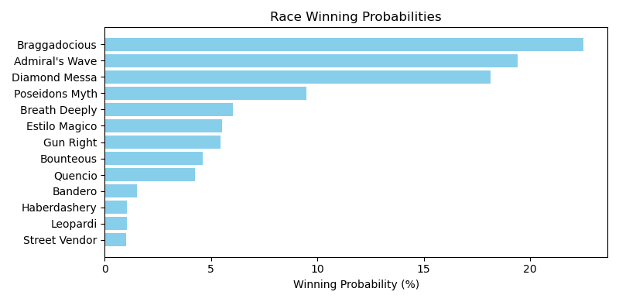

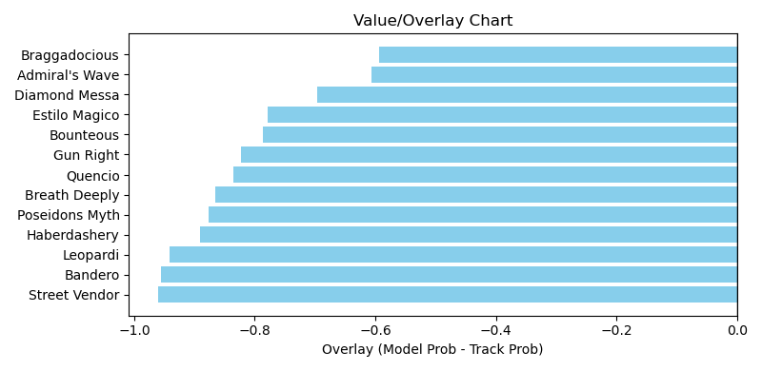

NOTE: GCSF - Global Combined Speed Figure

# Race: TAM | 2025-03-30 | Race #3 | Post: 13:06 | Track: TAMPA BAY DOWNS

Track: TAMPA BAY DOWNS

|  |  |  |  |  |  |
| --- | --- | --- | --- | --- | --- |
| Program # | Horse Name | Morn Odds | GCSF | Model Score | Win Prob (%) |
| 1 | CURRENCY ADIOS | 8-1 | 100.0 | 1.00 | 7.02 |
| 2 | RED MILLER | 5-2 | 100.0 | 1.19 | 14.66 |
| 3 | DIVINE PEACE | 8-1 | 100.0 | 1.04 | 8.15 |
| 4 | Pico Plat | 9-2 | 93.4 | 0.75 | 2.01 |
| 5 | KING GERALD | 9-2 | 100.0 | 1.03 | 7.84 |
| 6 | Dreamliner's Kid | 15-1 | 100.0 | 1.27 | 19.47 |
| 7 | Bridoza | 3-1 | 100.0 | 1.30 | 21.66 |
| 8 | Love Bucks | 15-1 | 106.6 | 0.99 | 6.69 |
| 9 | What a Steal | 30-1 | 100.0 | 1.14 | 12.50 |

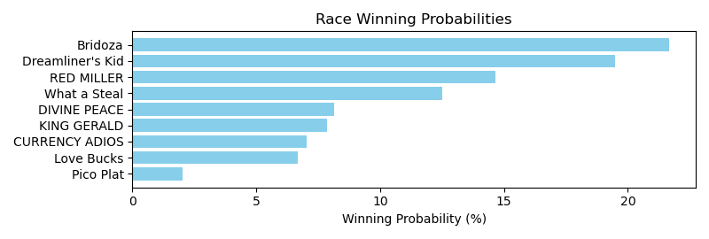

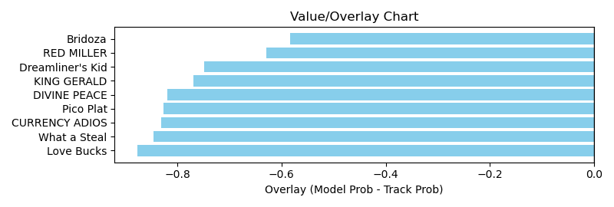

NOTE: GCSF - Global Combined Speed Figure

# Race: TAM | 2025-03-30 | Race #4 | Post: 13:39 | Track: TAMPA BAY DOWNS

Track: TAMPA BAY DOWNS

|  |  |  |  |  |  |
| --- | --- | --- | --- | --- | --- |
| Program # | Horse Name | Morn Odds | GCSF | Model Score | Win Prob (%) |
| 1 | Cajun Venom | 20-1 | 96.3 | 1.04 | 8.76 |
| 2 | Mad House | 3-1 | 100.0 | 1.32 | 25.44 |
| 3 | Centerfold Guy | 30-1 | 93.0 | 0.67 | 1.28 |
| 4 | Rip Riding Away | 15-1 | 100.5 | 0.94 | 5.79 |
| 5 | Just Relax | 10-1 | 90.7 | 1.09 | 10.82 |
| 6 | Macho Music | 1-2 | 93.1 | 1.46 | 39.01 |
| 7 | P Four | 8-1 | 106.6 | 1.04 | 8.89 |

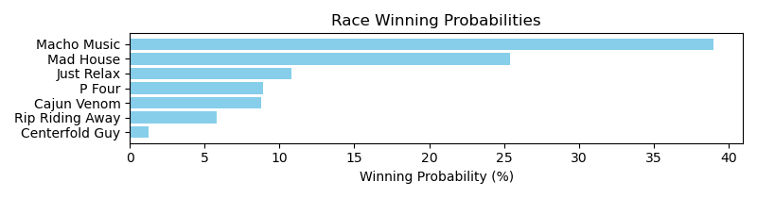

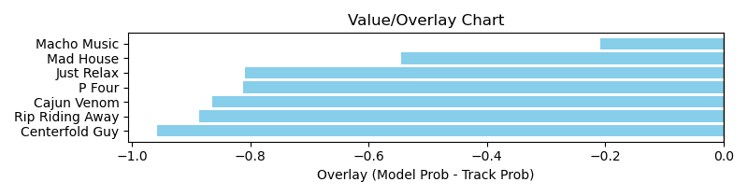

NOTE: GCSF - Global Combined Speed Figure

# Race: TAM | 2025-03-30 | Race #5 | Post: 14:12 | Track: TAMPA BAY DOWNS

Track: TAMPA BAY DOWNS

|  |  |  |  |  |  |
| --- | --- | --- | --- | --- | --- |
| Program # | Horse Name | Morn Odds | GCSF | Model Score | Win Prob (%) |
| 1 | Uncommon | 7-2 | 100.0 | 1.41 | 17.43 |
| 2 | Inesperee | 8-1 | 100.0 | 1.13 | 6.51 |
| 3 | Romina | 15-1 | 100.0 | 1.25 | 10.19 |
| 4 | MIMZY (IRE) | 3-1 | 100.0 | 1.25 | 10.41 |
| 5 | Bella Alessia | 20-1 | 93.4 | 0.65 | 0.58 |
| 6 | Calla | 30-1 | 100.0 | 1.24 | 9.84 |
| 7 | Sugarfina | 15-1 | 100.0 | 1.07 | 5.20 |
| 8 | Subsidy | 8-1 | 100.0 | 1.27 | 11.03 |
| 9 | Mona L | 8-1 | 93.4 | 0.81 | 1.55 |
| 10 | Stillthinkingofyou | 9-2 | 91.8 | 1.24 | 10.08 |
| 11 | Dimensionality | 8-1 | 105.2 | 1.25 | 10.31 |
| 12 | Villa La Pausa | 30-1 | 100.0 | 1.14 | 6.87 |

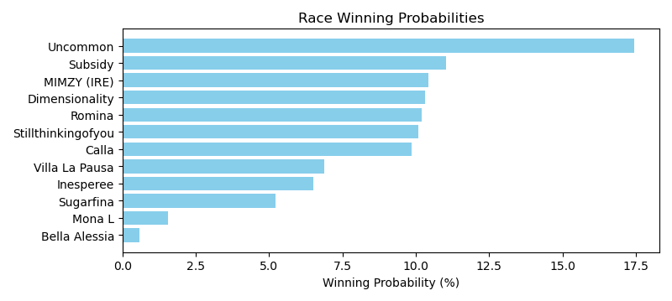

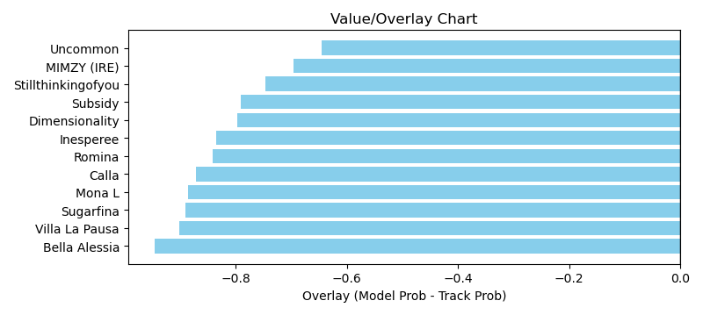

NOTE: GCSF - Global Combined Speed Figure

# Race: TAM | 2025-03-30 | Race #6 | Post: 14:45 | Track: TAMPA BAY DOWNS

Track: TAMPA BAY DOWNS

|  |  |  |  |  |  |
| --- | --- | --- | --- | --- | --- |
| Program # | Horse Name | Morn Odds | GCSF | Model Score | Win Prob (%) |
| 1 | Practicality | 7-2 | 88.0 | 1.13 | 12.20 |
| 2 | Qualificata | 10-1 | 92.7 | 1.07 | 9.50 |
| 3 | Moretastic | 9-2 | 110.2 | 1.14 | 12.31 |
| 4 | Awesome Empress | 8-1 | 99.0 | 0.98 | 6.58 |
| 5 | Awesome Pic | 10-1 | 100.5 | 1.09 | 10.43 |
| 6 | It's Goodtobe Jose | 12-1 | 94.9 | 1.08 | 9.84 |
| 7 | Factorbella | 3-1 | 97.4 | 1.22 | 16.57 |
| 8 | Just Mercy | 15-1 | 98.0 | 1.00 | 7.07 |
| 9 | Athena's Wisdom | 9-2 | 101.4 | 1.20 | 15.49 |

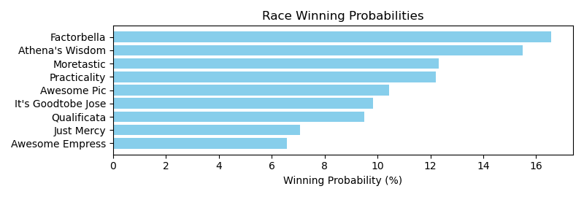

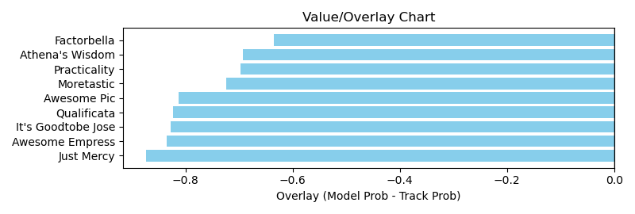

NOTE: GCSF - Global Combined Speed Figure

# Race: TAM | 2025-03-30 | Race #7 | Post: 15:18 | Track: TAMPA BAY DOWNS

Track: TAMPA BAY DOWNS

|  |  |  |  |  |  |
| --- | --- | --- | --- | --- | --- |
| Program # | Horse Name | Morn Odds | GCSF | Model Score | Win Prob (%) |
| 1 | Frida | 4-1 | 91.1 | 0.75 | 1.10 |
| 2 | Hey Cookie | 8-1 | 100.0 | 1.37 | 15.62 |
| 3 | Spirited Boss | 6-1 | 99.1 | 1.26 | 10.84 |
| 4 | La Gioconda | 10-1 | 106.6 | 1.27 | 11.40 |
| 5 | Vuela Paloma | 12-1 | 95.8 | 1.06 | 5.06 |
| 6 | Win N Your In | 9-2 | 102.2 | 0.87 | 2.11 |
| 7 | R Morning Brew | 7-2 | 93.1 | 1.32 | 13.28 |
| 8 | Bella Cleopatra | 3-1 | 93.4 | 1.70 | 40.60 |

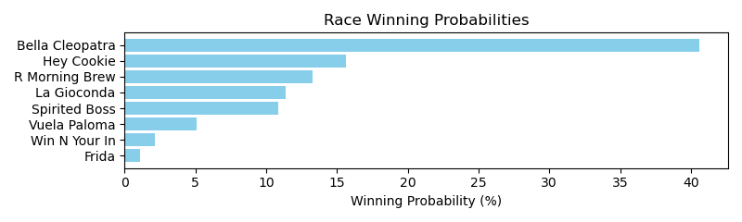

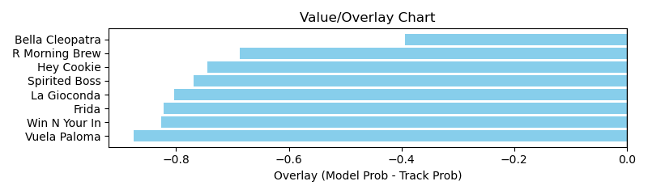

NOTE: GCSF - Global Combined Speed Figure

# Race: TAM | 2025-03-30 | Race #8 | Post: 15:48 | Track: TAMPA BAY DOWNS

Track: TAMPA BAY DOWNS

|  |  |  |  |  |  |
| --- | --- | --- | --- | --- | --- |
| Program # | Horse Name | Morn Odds | GCSF | Model Score | Win Prob (%) |
| 1 | Crystal Quest | 12-1 | 116.4 | 1.10 | 2.23 |
| 2 | Forever Souper | 2-1 | 105.0 | 1.74 | 16.77 |
| 3 | Drama Chorus | 15-1 | 112.9 | 1.17 | 2.97 |
| 4 | Lord Eddard Stark | 15-1 | 87.7 | 1.33 | 5.13 |
| 5 | Treasure King | 15-1 | 106.8 | 1.30 | 4.70 |
| 6 | dh-Happyisashappydoes | 30-1 | 106.1 | 0.98 | 1.39 |
| 7 | Street Earnings | 12-1 | 98.7 | 1.39 | 6.24 |
| 8 | Boppy O | 4-1 | 99.9 | 1.44 | 7.40 |
| 9 | Echo Lane | 9-2 | 106.5 | 1.82 | 20.64 |
| 10 | Ninja Star | 12-1 | 102.1 | 1.12 | 2.48 |
| 11 | Themanupfront | 20-1 | 105.9 | 1.17 | 2.94 |
| 12 | Otago | 10-1 | 117.6 | 1.94 | 27.11 |

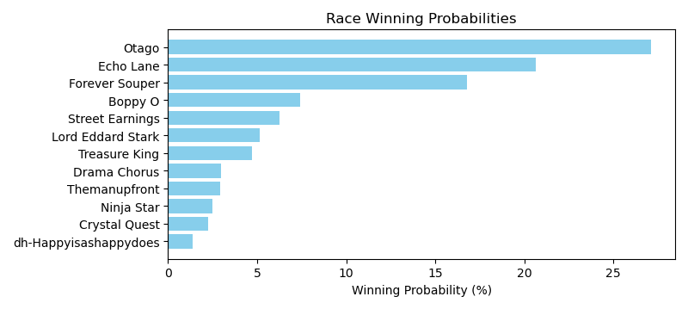

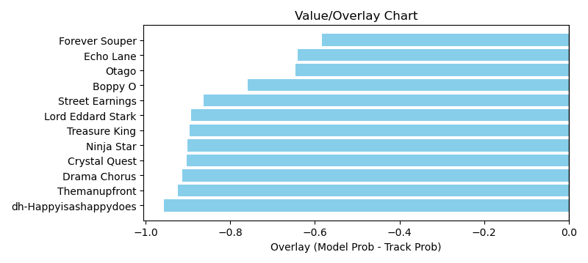

NOTE: GCSF - Global Combined Speed Figure

# Race: TAM | 2025-03-30 | Race #9 | Post: 16:25 | Track: TAMPA BAY DOWNS

Track: TAMPA BAY DOWNS

|  |  |  |  |  |  |
| --- | --- | --- | --- | --- | --- |
| Program # | Horse Name | Morn Odds | GCSF | Model Score | Win Prob (%) |
| 1 | Seat At the Table | 9-2 | 97.1 | 1.54 | 21.71 |
| 2 | Dancing N Dixie | 5-2 | 87.8 | 1.25 | 8.69 |
| 3 | Lady Lala | 30-1 | 106.7 | 0.83 | 1.45 |
| 4 | Princess Britni | 20-1 | 97.1 | 1.37 | 12.99 |
| 5 | Chick's Shadow | 9-2 | 93.2 | 1.29 | 10.04 |
| 6 | Amata | 30-1 | 106.6 | 1.08 | 4.62 |
| 7 | Lady Cha Cha | 8-1 | 96.7 | 1.17 | 6.61 |
| 8 | Vibrant Lady | 15-1 | 100.0 | 1.24 | 8.43 |
| 9 | Dreaming of Abba | 15-1 | 95.4 | 1.14 | 5.90 |
| 10 | Bedrock Birdie | 30-1 | 123.6 | 1.11 | 5.16 |
| 11 | Mohawk Trail | 4-1 | 98.7 | 1.14 | 5.95 |
| 12 | Lets Go Koko | 8-1 | 106.6 | 1.24 | 8.44 |

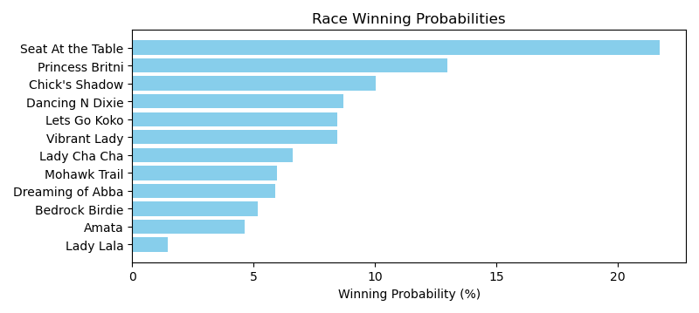

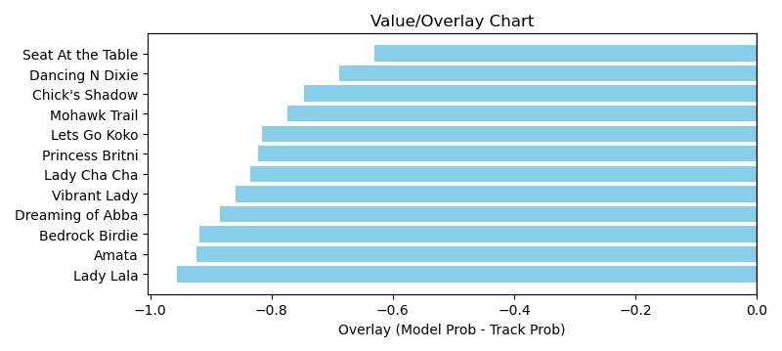

NOTE: GCSF - Global Combined Speed Figure

# Race: TAM | 2025-03-30 | Race #10 | Post: 17:07 | Track: TAMPA BAY DOWNS

Track: TAMPA BAY DOWNS

|  |  |  |  |  |  |
| --- | --- | --- | --- | --- | --- |
| Program # | Horse Name | Morn Odds | GCSF | Model Score | Win Prob (%) |
| 1 | Pure Class | 8-1 | 99.6 | 1.13 | 5.27 |
| 2 | Hurricane Nelson | 9-2 | 107.9 | 1.59 | 23.59 |
| 3 | Rouki | 6-1 | 96.9 | 1.35 | 11.73 |
| 4 | Comedy Town | 5-2 | 95.3 | 1.36 | 11.82 |
| 5 | Chrome Ghost | 8-1 | 96.5 | 1.18 | 6.48 |
| 6 | Mattingly | 8-1 | 106.5 | 1.23 | 7.66 |
| 7 | Classify | 4-1 | 98.6 | 1.41 | 13.79 |
| 8 | Big Effect | 10-1 | 98.0 | 1.09 | 4.62 |
| 9 | Fortysixcounts | 20-1 | 89.7 | 1.13 | 5.24 |
| 10 | Cajun Gem | 20-1 | 90.6 | 1.30 | 9.80 |

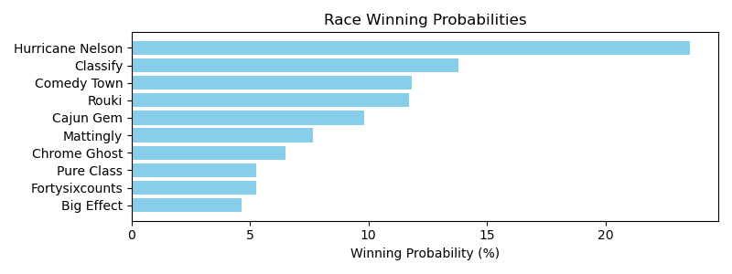

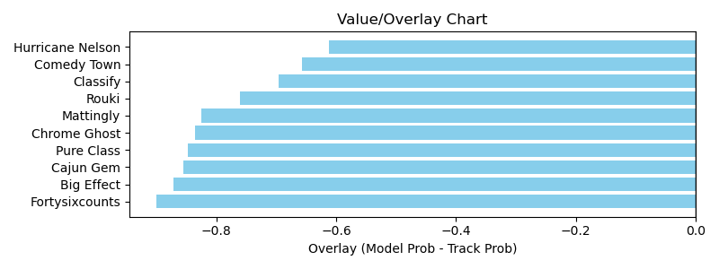

NOTE: GCSF - Global Combined Speed Figure

# Race: TAM | 2025-03-30 | Race #11 | Post: 17:37 | Track: TAMPA BAY DOWNS

Track: TAMPA BAY DOWNS

|  |  |  |  |  |  |
| --- | --- | --- | --- | --- | --- |
| Program # | Horse Name | Morn Odds | GCSF | Model Score | Win Prob (%) |
| 1 | Makoa | 20-1 | 95.3 | 0.79 | 1.59 |
| 2 | Nothingsubtle | 12-1 | 106.6 | 0.70 | 0.91 |
| 3 | Good Long Cry | 4-1 | 97.3 | 1.20 | 9.92 |
| 4 | Latch the Hatch | 6-1 | 106.6 | 1.39 | 18.69 |
| 5 | Bold N Breezy | 15-1 | 96.9 | 0.98 | 3.97 |
| 6 | Blue Casanova | 30-1 | 103.5 | 1.16 | 8.36 |
| 7 | Win With Faith | 7-2 | 100.7 | 1.57 | 31.91 |
| 8 | Koctel War | 12-1 | 106.6 | 1.19 | 9.28 |
| 9 | Tank | 3-1 | 94.9 | 1.09 | 6.50 |
| 10 | Emmett | 9-2 | 108.1 | 1.17 | 8.88 |

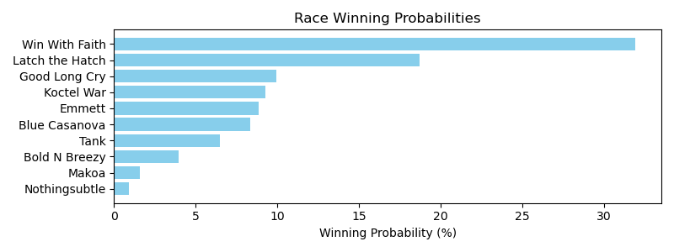

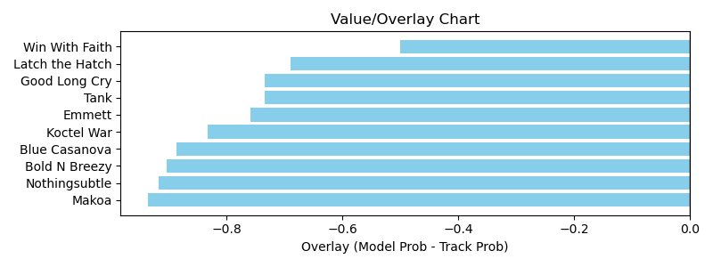

NOTE: GCSF - Global Combined Speed Figure